What to do
Reading
IMPORTANT Parent or Carer –
Please check that you are happy with any weblinks or use of the internet.

Our focus today is reading.

1. Read a book

Look at the cover of Scooters. What sort of book does this look like? Will it be a story book or one with information in (non-fiction)? Read the book together, taking time to enjoy the pictures and read the words.

2. Respond to the book

- Talk about the book. What was it about? What can we find out about scooters in this book? Look through the first few pages and read some facts together, e.g. ‘Scooters can have two wheels or three wheels.’
- Talk about the different things the boy likes to do on his scooter. Find the right pages and read the words together. Does your child enjoy scooting or a similar activity?
- What part of the book was surprising or funny? Talk about the imagined animal scooters and funny places to scoot. Which is your child’s favourite? Can they explain why?
  - Discuss the question on Where would you scoot if you could?
  - Talk about your ideas. They can be realistic or fantastical.
  - Together, write a sentence or two about where you would go and/or draw a picture. The emphasis is on talking about ideas and explaining thoughts, so it is fine to write for your child if they find this hard.

Try these Fun-Time Extras

- Read Biking (see below) and talk about the poem.
- Read books about transport or go out and find different examples on a walk.
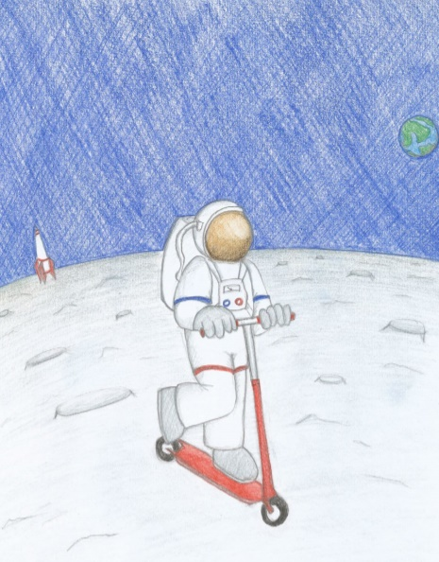
Where would you scoot if you could?

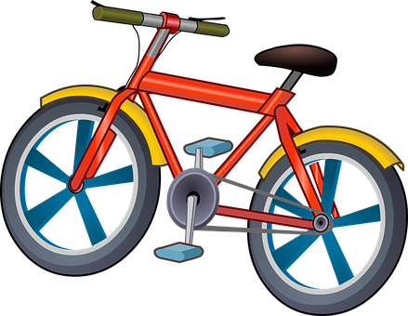
Biking
Judith Nicholls

Fingers grip,
toes curl;
head down,
wheels whirl.

Hair streams,
fields race;
ears sting,
winds chase.

Breath deep,
troubles gone;
just feel
windsong.

Taken from The Puffin Book of Fantastic First Poems page 73

