What to do
Reading
IMPORTANT Parent or Carer –
Please check that you are happy with any weblinks or use of the internet.

Our focus today is reading.

1. Read a book

Look at the cover of Superheroes – All sorts. What sort of superheroes might be in this book? Read the book together, taking time to enjoy the pictures.

2. Respond to the book

- Talk about the book. What sort of book is this? It is not a story book about superheroes. It is like an information book, telling us about the different types of superhero. Were you surprised by the type of superheroes described? How are they different from other story book superheroes? What do they do to help people around them?
- Pick a superhero page to discuss (computer, beach, park, etc.). Read the words on that page. Why is help needed? How might that superhero help? What power would they use?
  - Look at the illustration below on How can they help?
  - Talk about what they might do to help in both places. Pick out details and talk about what could go wrong and how the hero could help.
  - Write a sentence or two about one or both heroes describing how they help. This could be in a traditional superhero way or in an everyday way, in the spirit of the book.

Try these Fun-Time Extras

- Read We Are All Superheroes together (see below) and develop actions for each part of the poem.
- Enjoy stories about superheroes in books, comics and on screen.
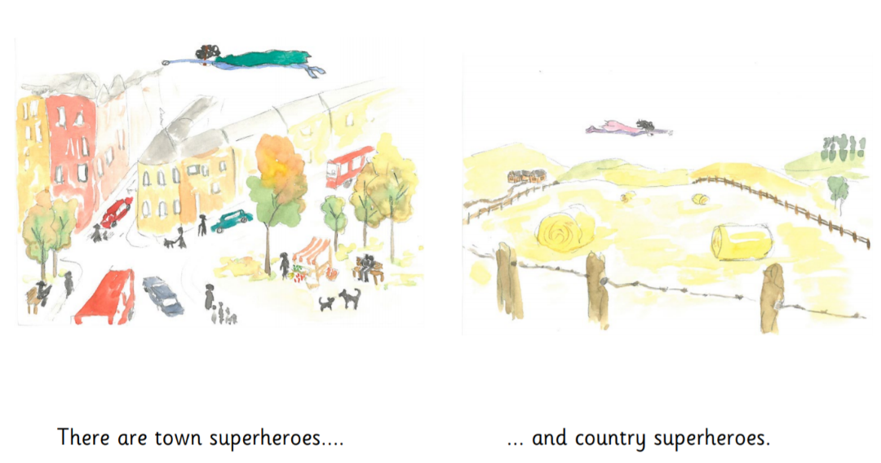
How can they help?

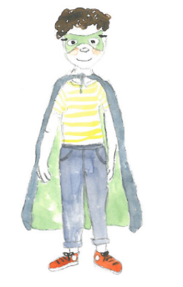
We Are All Superheroes

Wake up superheroes,
Someone is in trouble!
Put on your masks,
Quick - at the double!

Twirl in your capes.
Are you ready to fly?
Hands on your hips.
Hold your heads up high.

Test out your muscles.
Are they mighty and strong?
Can you use super-thinking
To sort out what’s wrong?

We work as a team here.
Together we show,
We are all superheroes,
Ready to go!

