What to do
Writing
IMPORTANT Parent or Carer –
Please check that you are happy with any weblinks or use of the internet.

Our focus today is writing.

1. Discuss a book.

Read Scooters together, noticing the different illustrations and how they link to the words on the page.

2. Write a new page for a book.

  - Remind your child how the book ends with a question. Read it together. Today you will be writing a new page for the book which answers this question. You will need some writing and an illustration.
  - Build a sentence or two verbally to answer the question, encouraging your child to extend their sentence with a word like ‘because’, ‘but’ or ‘as’, e.g. I like scooters because you can go really fast. or I don’t like scooters as they are too bumpy on rough ground.
  - When you have built a sentence verbally, write each word, sounding out the letters, together on A new page for Scooters below.

NB. Getting young children to write is not easy! See Guidance and handwriting groups below.

Try these Fun-Time Extras

- Make your own book about transport by folding paper. You could draw or print pictures of buses, trains, bikes, or rockets on each page and write some sentences to go with them.
- Draw a diagram of a transport item, such as a bike, tram, or car. Find out the proper names for different parts and write labels for them, e.g. mudguard, hubcap, roof, bonnet etc.
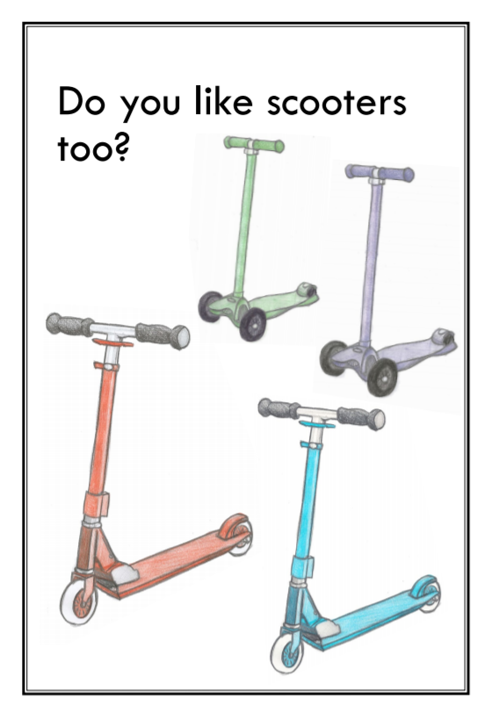
A new page for Scooters

Guidance for writing – some dos and don’ts

- DO focus on letter formation. See sheet below. It’s really important that children get into the habit of writing letters correctly – this is not about how the finished letter looks, it’s all about how they write it – what direction they move the pencil or pen. Bad habits are almost impossible to break – if they form letters wrongly, the finished letter may look good BUT in the long run, they are much less likely to be able to write fluently.

- DON’T write a word or a line for them to copy. If they can’t remember how to write a letter, demonstrate, forming it correctly, so that they can imitate you.

- DO give loads of praise. Writing is so hard, and children get discouraged easily. It may be that they have just written one or two words, but if you praise them, it may be four words next time!

- DON’T do ‘dotty’ letters for them to trace. It is much better for children to form their own letters. We are teaching them to write not trace!

- DO write for them sometimes. It is important that young children can express their ideas in written form, and sometimes it is really good to write down what they say so that their ideas are expressed in writing on the page. Sometimes you can take turns to scribe. You write a bit, then they write a bit.

