Hello Class 4,
It was lovely to speak to most of you on the phone last week and I am VERY pleased that you have been trying hard with your learning at home over the last few months. If I haven’t caught up with you yet, I will try to contact you again this week.
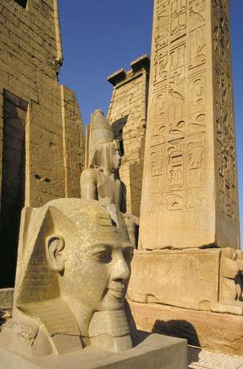
This week’s learning will be based on the theme of the Ancient Egyptians and I hope you like it.
English:
I have put this week’s spellings for you to learn at the end of this document as usual.
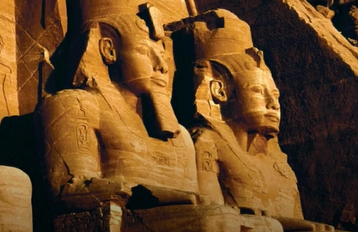
For your writing this week, I would like you to research the amazing sites of Luxor in Egypt.
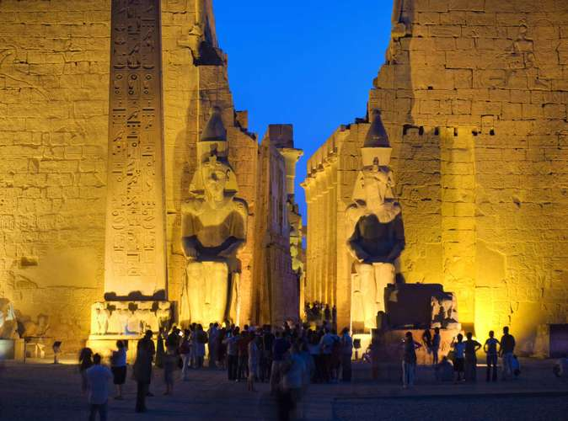
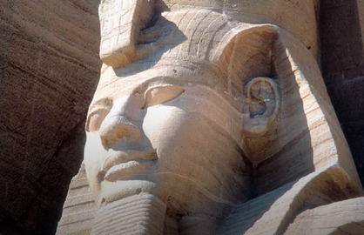

After collecting your information, I would like you to either:
- Write a hotel brochure for a holiday to Luxor
- Write an information text about the Valley of the KIngs
- Write a short story entitled: ‘The Curse of the Mummy’ (Try not to make it too much like a Scooby Doo episode though!)
Example of Hotel Holiday Brochure information:
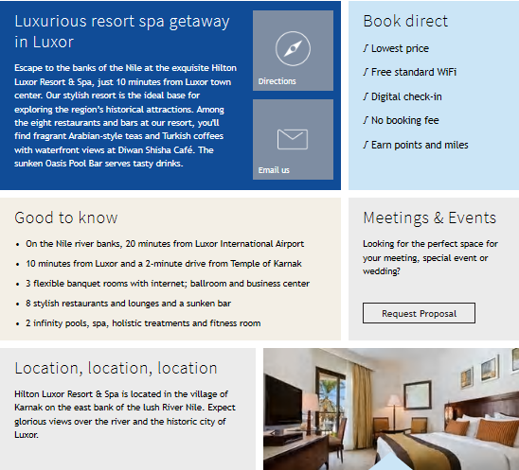

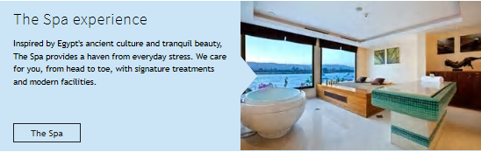

Features of an information text
- Main title - This sums up the topic
- Headings and sub-headings - these are used to introduce the content of different paragraphs to help the reader navigate the text.
- Paragraphs - these are the main bodies of text that include the topic information.
- Bullet-pointed lists - Ordering key information in a list is a great way of telling the reader what they need to know about the subject.
- Photographs and illustrations - information texts include images to make the information easier to understand. These can be realistic photos or annotated diagrams.
- Captions - captions are used to describe included photographs and illustrations.

The Valley of the Kings was a great burial ground for the Pharaohs. After around 1500 B.C. the Pharaohs no longer built great pyramids in which to be buried. Instead, most of them were buried in tombs in the Valley of the Kings.
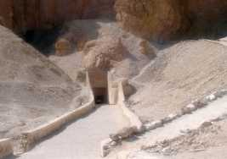
Tomb at Valley of the Kings.
How Many Tombs are in the Valley of the Kings?
There are over 60 tombs in the Valley of the Kings. They vary from small tombs that are little more than a large hole in the ground to very large tombs with over 100 underground chambers.
Unfortunately, most of the tombs were looted thousands of years ago and the treasure was stolen or removed by thieves. There is artwork on the walls, however, that allows archeologists to learn much about the lives of the Pharaohs and other leaders who were buried here. The one tomb that was discovered with much of the treasure and tomb still intact was that of Tutankhamun.
The Tomb of Tutankhamun
The most famous tomb in the Valley of the Kings is that of the Pharaoh Tutankhamun, sometimes called King Tut. It was discovered in 1922 by Howard Carter and had been largely untouched by thieves and vandals. Carter found the tomb under the remains of some workmen's huts. This may be why it had not been found by tomb raiders. The tomb was packed with amazing artifacts including King Tut's mummy, a gold mask, and a solid gold inner coffin. The tomb contained several chambers including the burial chamber, antechamber, treasure chamber, and annex.
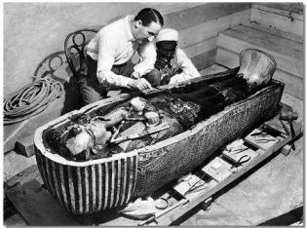
Tut's Tomb from the New York Times
King Tut's Curse
There is a long standing mystery about the curse of King Tut's tomb. Rumour had it that a tablet inside the tomb had a curse on it and Howard Carter hid the tablet so his workers wouldn't know. However, the rumours of a curse are most likely made up. There weren't a lot of deaths or bad things that happened to those who opened the tomb or Tutankhamen's mummy.
Who else was buried here?
The first Pharaoh to be buried in the Valley of the Kings was Tuthmosis I. Over the next 500 years many more Pharaohs were buried here including many of the Rameses (I, II, III, IV, V, VI, VII, IX, X), Hatshepsut, Amenhotep I, and Tutankhamun.
Fun Facts about the Valley of the Kings
- Today tourists can visit many of the tombs including Tutankhamun's.
- There is graffiti on the tombs from other cultures and times including Greek, Latin, and Phoenician.
- Although we don't know who was Pharaoh during the Exodus in the Bible, due to the time frame, it is likely that he was buried in the Valley of the Kings.
- Tomb workers lived in a close by town called Deir El Medina.
- Tutankhamun was buried with a lock of hair from his grandmother.
(Source: www.duckers.com)
RE: The Story of Moses
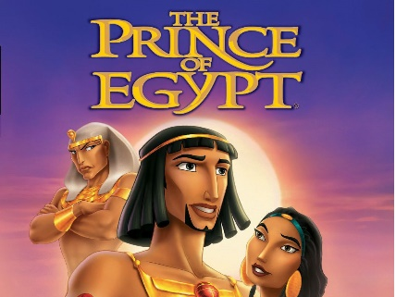
OPTIONAL: Watch ‘The Prince of Egypt’ (Certificate ‘U’-suitable for all) which tells the story of how Moses freed his people from the slavery of the Egyptians, and can also be found in the New Testament in the book of Exodus. It is available on Amazon Prime Video-but unfortunately not Netflix- and can be viewed on Youtube.

Task: Produce a storyboard to illustrate the ten plagues that God used Moses to deliver to the Egyptian people. The following link may help you and I’ve also posted a Powerpoint presentation for this week.
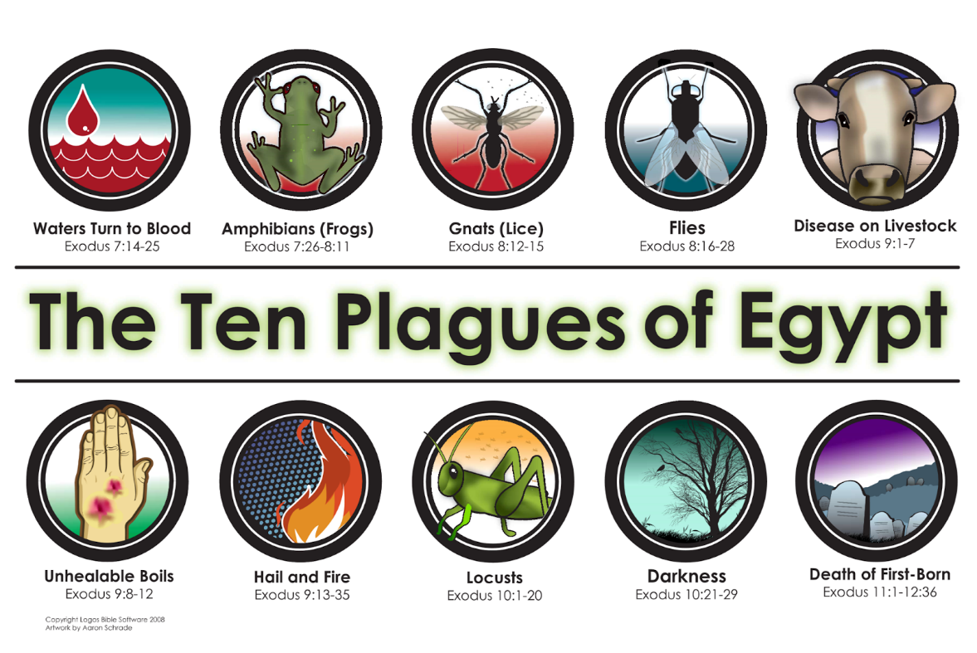
https://www.bbc.co.uk/bitesize/clips/zbsb9j6

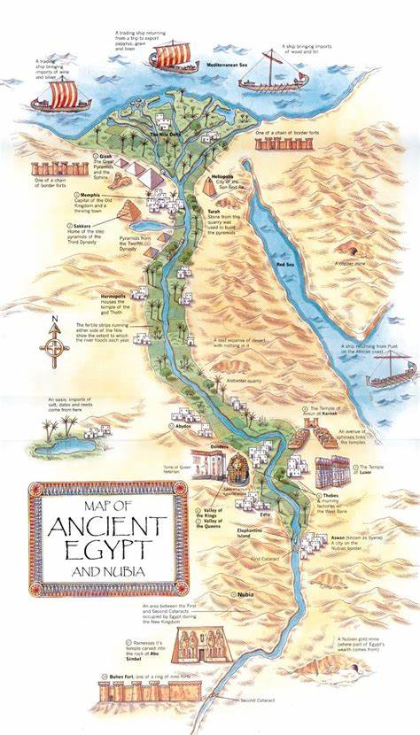
Geography:
Egypt Quiz
- In which continent is Egypt located?
- What is the capital city of Egypt?
- What are the main religions of Egypt in modern times?
- How many people live in Egypt? How does this compare to the UK?
- Egypt has a desert climate with ________ summers and ________ winters.
- What is the highest point in Egypt?
- How long is the Nile?
- Can you list all the countries that it flows through?
- How old was Tutankhamun when he became king?
- About how many years ago was the Sphinx constructed?
- Look carefully at the map to the left. Write a short paragraph about why the Nile is so important to the people of Egypt.
- How do Egyptian farmers use the Nile? How do they move water quickly?
- What animals live in the Nile?
- What is the name of the desert that covers Egypt?
- Is the Sahara desert getting larger or smaller? Can you explain why?
- True or false: Camels hold a store of water in their hump?
- Can you name these animals of the Sahara?

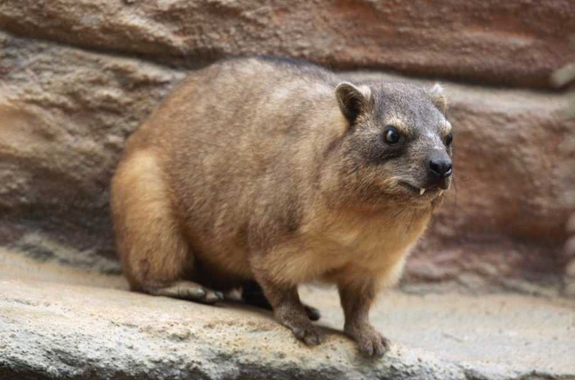
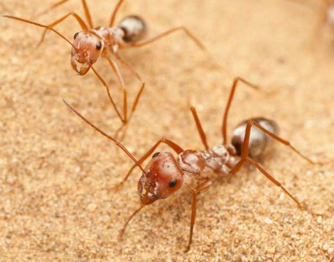
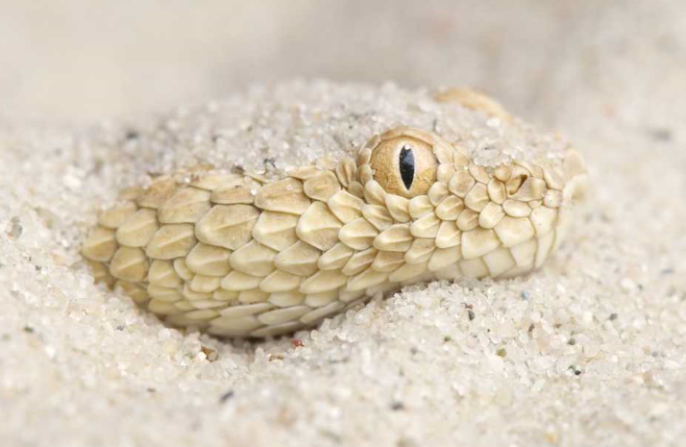

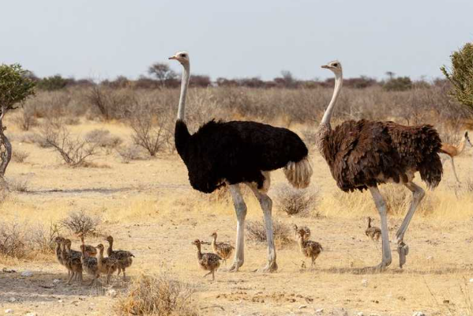
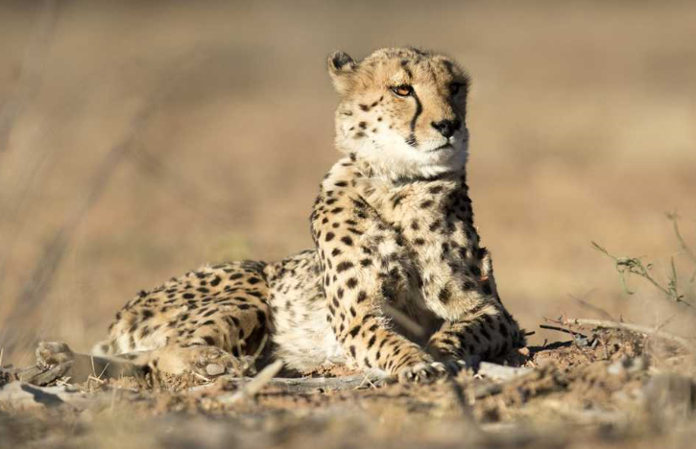

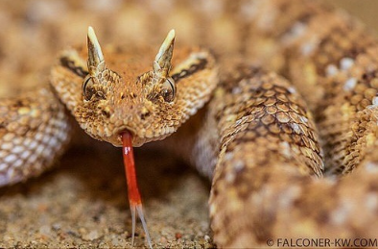
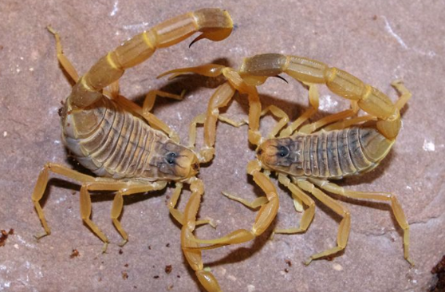

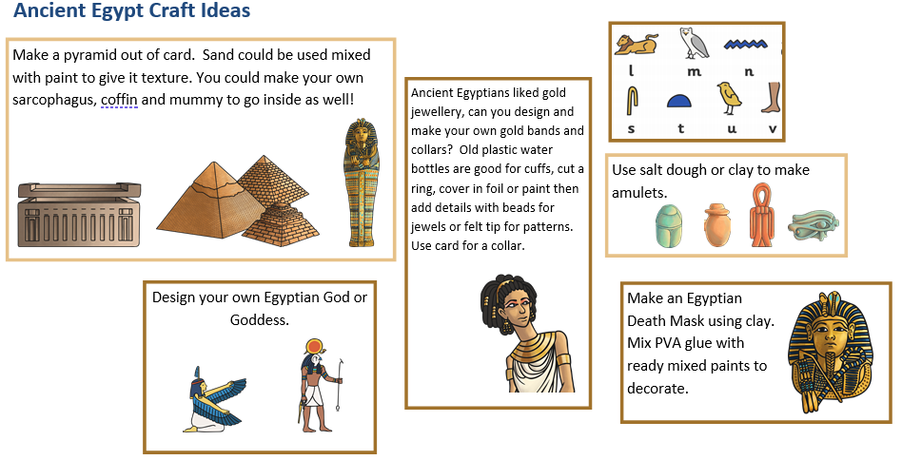
Art/Design Technology

Maths:
Task One: Complete the ‘I’m Thinking of a Number’ challenge cards. This is appropriate for both Year 5 & Year 6. As usual, there are three varying levels of difficulty (* = easier, ** = medium, *** = hard).
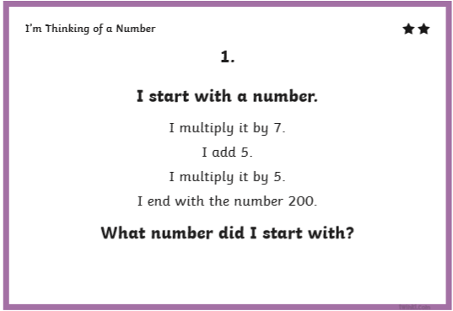
Example of how to do these:
n x 7 + 5 x 5 = 200
You then need to work backwards. + becomes - & x becomes ÷:
200 ÷ 5 -5 ÷7 = n
Answer: 200 ÷ 5 = 40 (because 20 ÷ 5 = 4)
40 – 5 = 35
35 ÷ 7 = 5 The missing number (n) is 5!

For the rest of the week, I’d like you to try two pages per day of the revision questions that I have included in this week’s maths work. There are separate sections for Year 5 & 6.

This week’s spelling lists:
Class 4 spelling list for group 3: Week 37
Objective: To spell words from the Year National Curriculum word lists.
Spellings | Look, cover, write, check
 | Monday | Tuesday | Wednesday | Thursday
actual
material
accident
medicine
business
naughty
calendar
notice
consider
opposite
experiment
ordinary
guide
particular
heard
perhaps
history
possible
interest
increase

Spelling score this week =

Class 2 spelling list for group 2: Week 37
Objective: To spell words from the National Curriculum word lists.
Spellings | Look, cover, write, check
 | Monday | Tuesday | Wednesday | Thursday
experience
sufficient
disappear
temperature
favourite
criticise
important
through
ordinary
vehicle
possible
communicate
probably
explanation
definite
definitely
especially
desperate
opportunity
persuade

Spelling score this week =

Class 2 spelling list for group 1: Week 37
Objective: To spell words from the National Curriculum word lists.
Spellings | Look, cover, write, check
 | Monday | Tuesday | Wednesday | Thursday
sufficiently
conscious
temperature
conscience
criticise
curiosity
thorough
hindrance
vehicle
physical
communicate
vegetable
explanation
achievement
definitely
immediately
desperately
occasionally
persuade
necessary

Spelling score this week =

As always, don’t worry if you cannot get through everything. Just try to do some reading. writing and mathematics each week.

Mr. Smith

