Hello Class 4!
It is strange to think that when I last saw you in March that you’d all still be working at home, but I just wanted to repeat how proud I am of you all for getting to the end of the school year, and to thank you for all your hard work and efforts . I know that it hasn’t been easy at times because I have also had to home-school my children too.
A special congratulations to Year 6. This is your last week of primary school and I know it must feel quite strange: a mixture of sadness and excitement about starting at your new school in September. I will be posting a video message to you all on our website towards the end of the week and you’ll also be receiving a ‘special delivery’ sometime soon.
Year 5, I look forward to seeing you all again when school re-opens fully.
For this week’s home learning, I’d like you to have a go at the following (I realise that this document has many pages, but I’ve tried to put everything in one place this week):
English:
This week, I am not giving you a spelling list. Instead, towards the end of this document, you’ll find lists of ALL the spellings you are expected to know by heart (gulp!) Don’t worry if you don’t know a few of them; but try some random ‘tests’ with who is helping you at home to identify the ones you need to work on a little bit more.
For the rest of the week, I’d like you to write a biography of somebody who inspires you. You could choose someone like Tiger Woods (if you like golf), Markus "Notch" Persson (if you are a Minecraft fan), one of our past kings, queens, or military heroes (if you love history), an inventor (such as Margaret Knight or Alexander Graham Bell); or another key historical figure who has worked towards changing the world into a better place (such as Marie Curie) – anyone you like!
To write a good biography, you’ll first need to do some research about the person you are choosing and try to collect information and facts from different times in their life. If possible, see if you can find out any amusing stories about what they have gone through to make your writing more entertaining for the reader.
Next, you’ll need to organise your notes into a chronological order and think of suitable chapter/sub-headings. This will you to structure your writing and may look something like this (but you don’t have to stick to these):
Early life (include birth date, where they were born and what was it like there? Who their parents were/are)
School days (names of schools they attended + memories/amusing stories. What were their dreams? Did anyone influence / guide them to what they would go on to achieve?)
The next paragraphs will very much depend on who you choose. If it’s an author, it could be about their first book being published after struggling to break through. If it is a sports person, you could find out about how they worked hard to slowly achieve their dream.
To help you, you might want to look at the following link, as it has lots of great examples to read through:
https://www.ducksters.com/biography/
A great biography which I have enjoyed reading many times is Roald Dahl’s ‘Boy.’ It’s full of funny little episodes to make you laugh and is well worth a read if you can get hold of a copy. 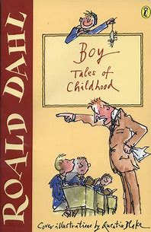
Mathematics:
This week I’ve chosen a few pages from our Maths ‘On Target’ books for you to try. They are the review pages and are good revision material, so if you don’t get through them all this week, they are certainly pages worth going back to. If you find anything too hard, just try your best! You can also make use of the tips and advice on: https://www.bbc.co.uk/bitesize/subjects/z826n39
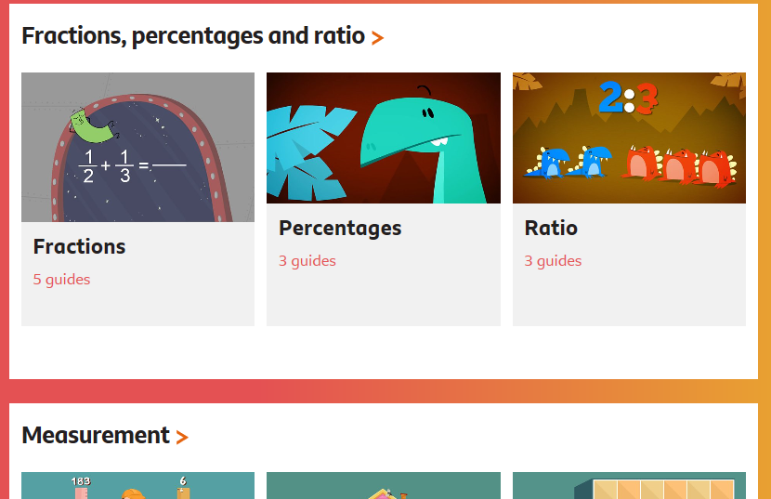

See next pages for ‘On Target’ maths work, and don’t forget that you can work from the screen on your device to save printing costs and materials.

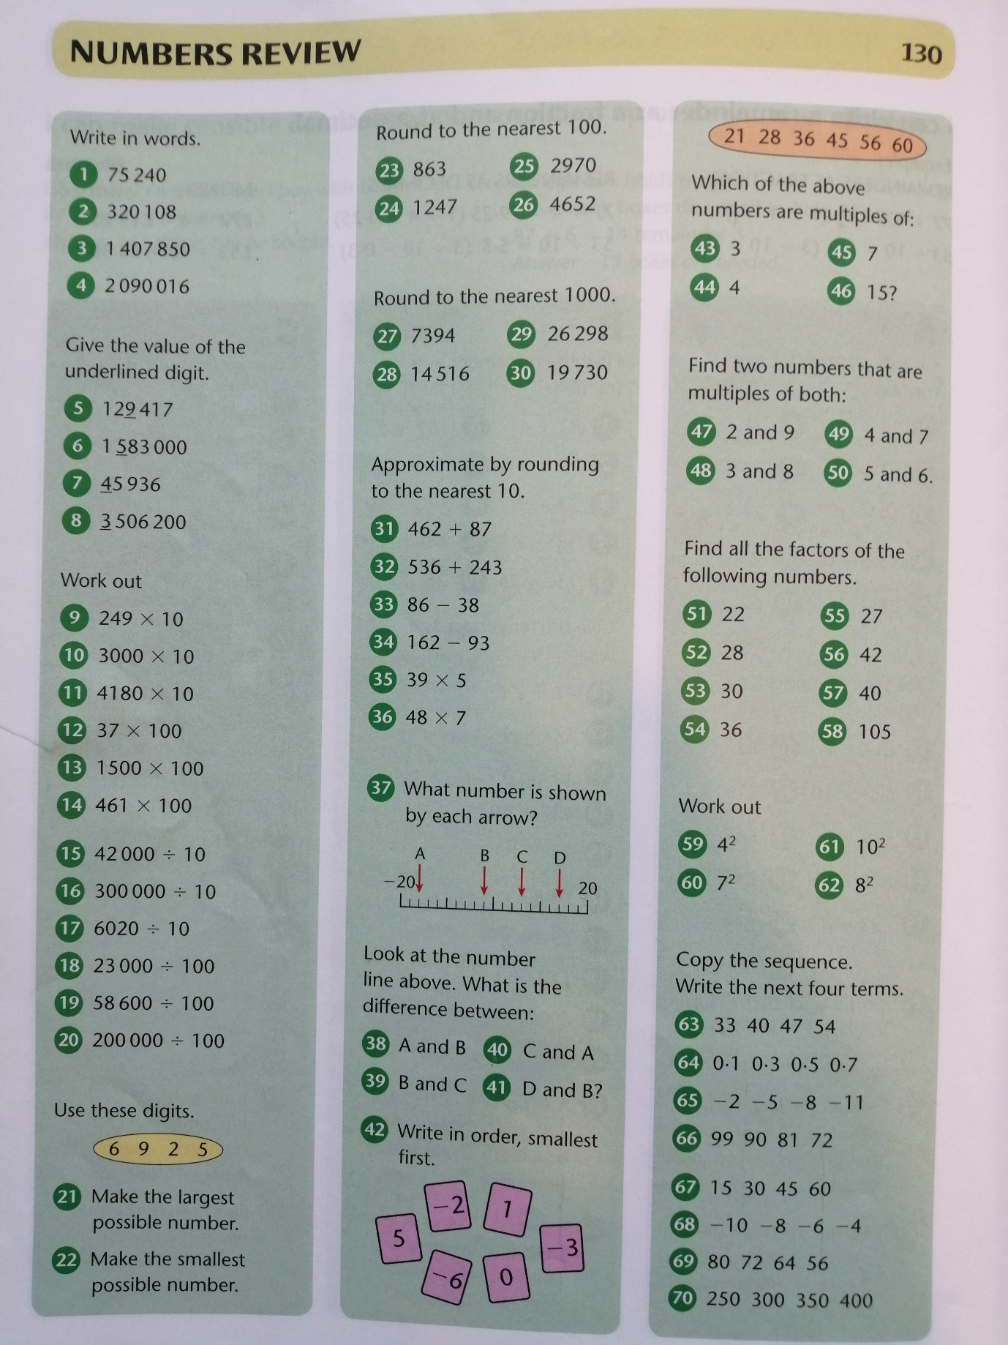
Year 5 mathematics:

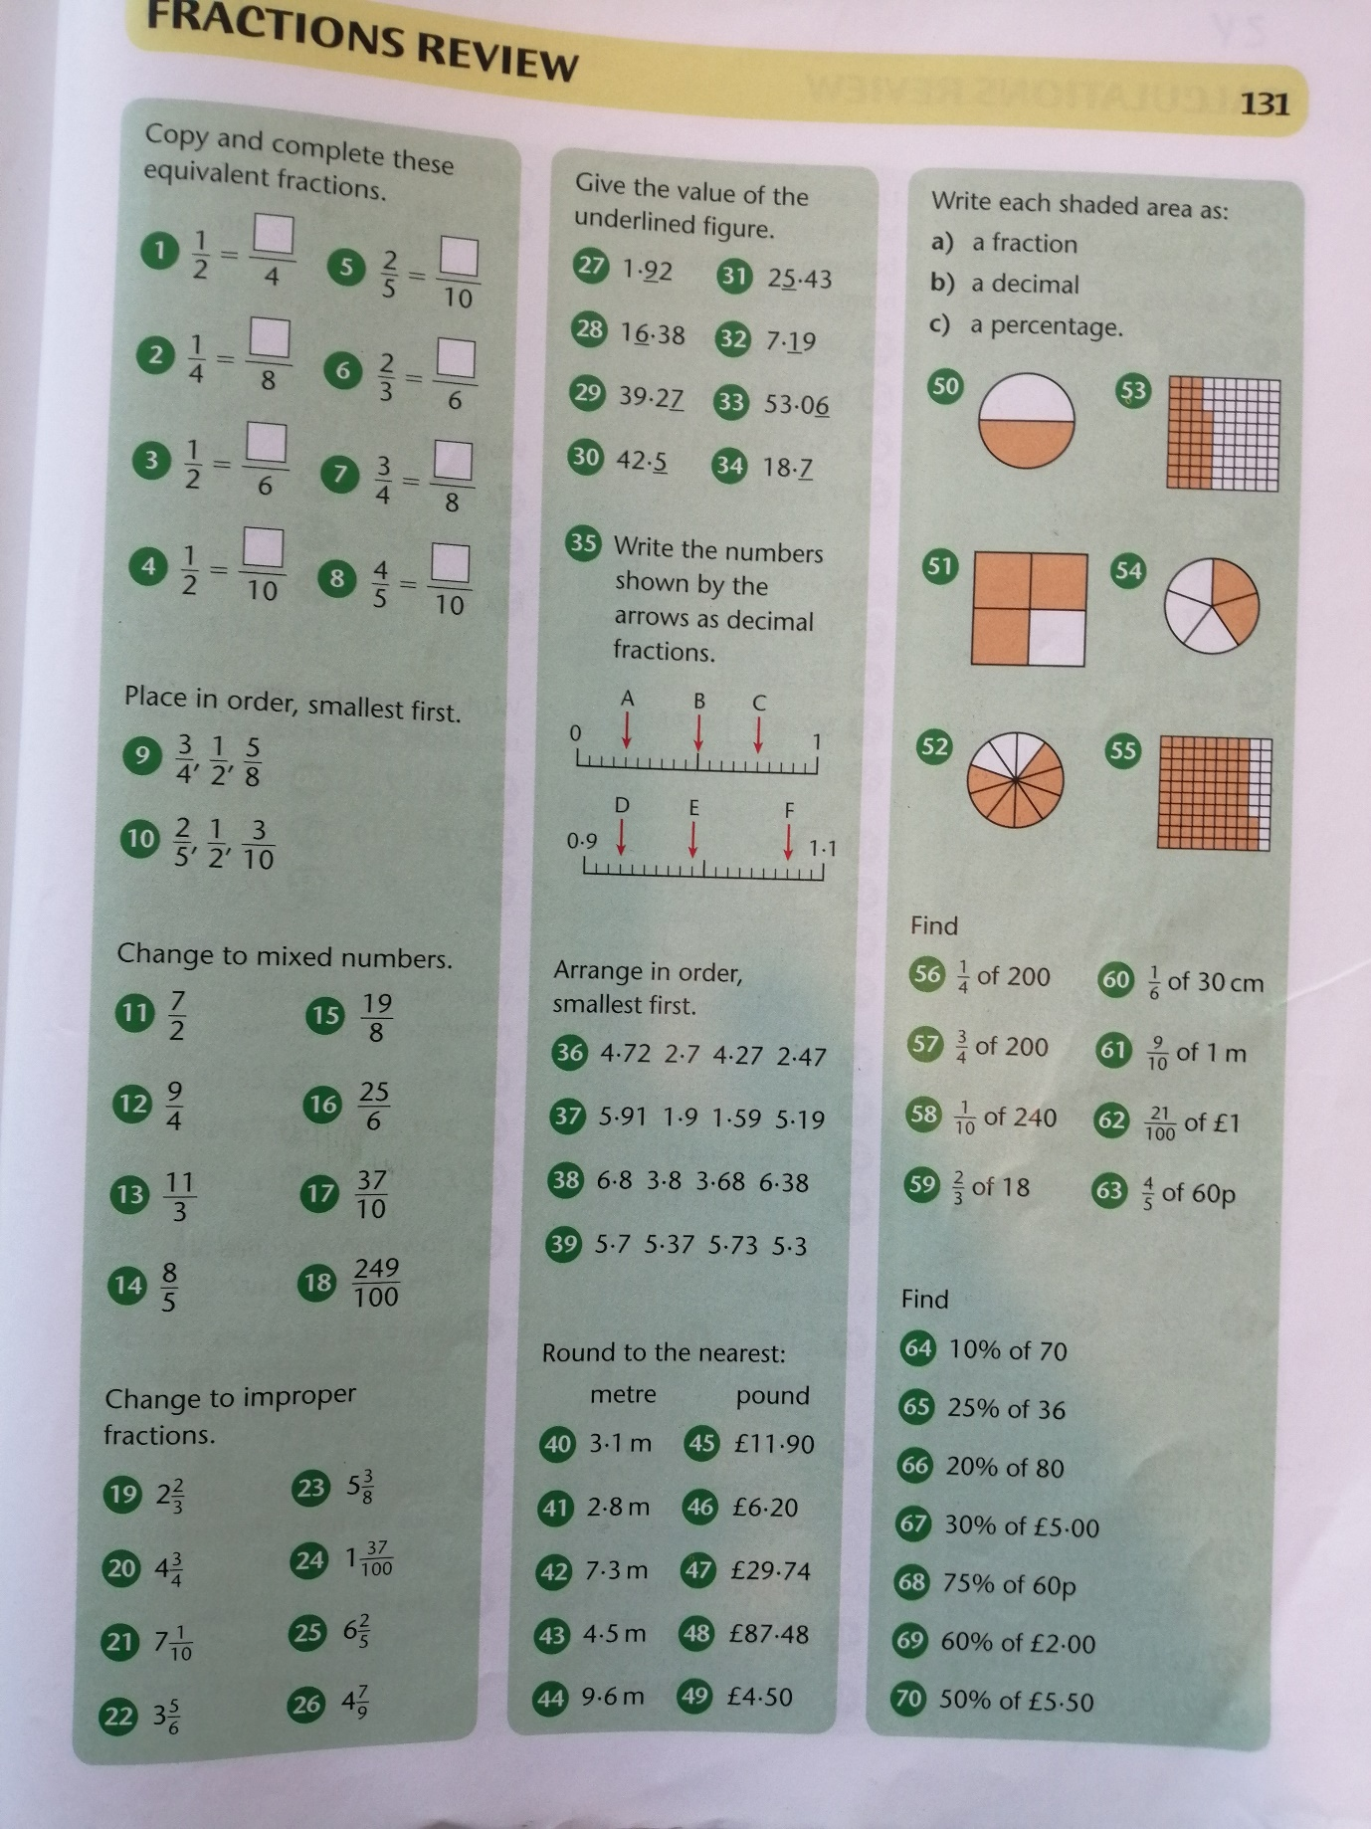
Year 5 mathematics:

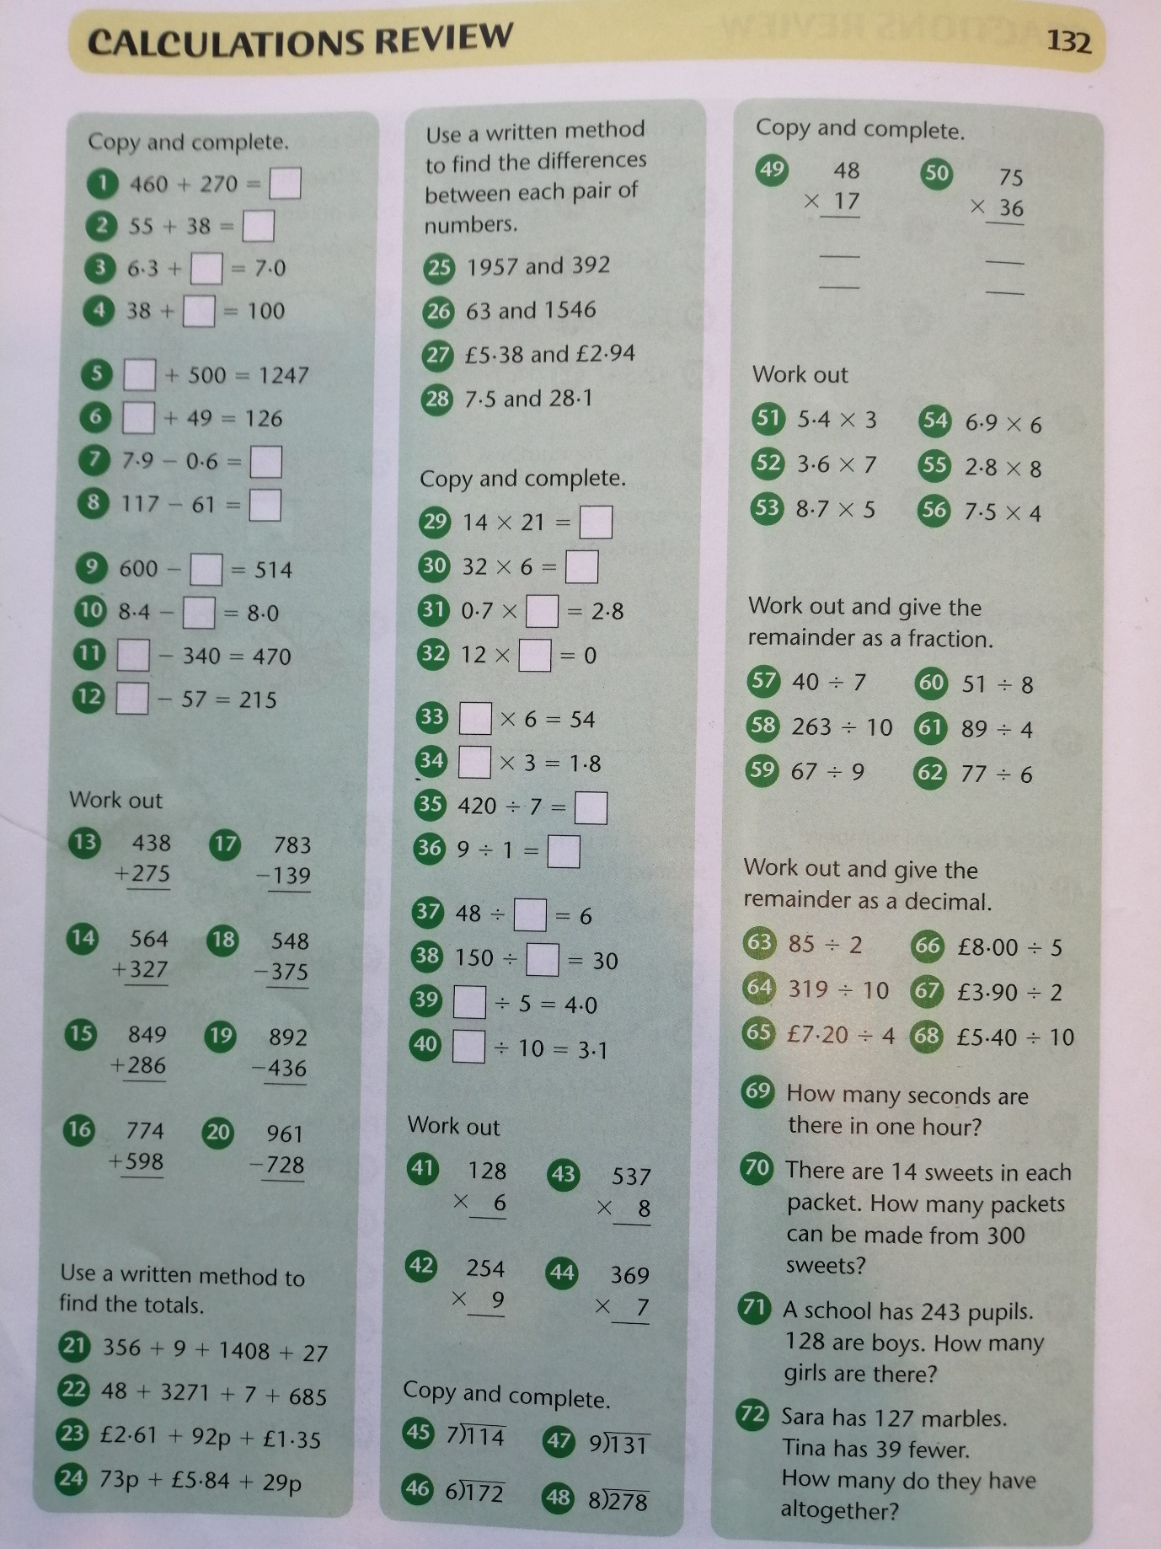
Year 5 mathematics:

Year 5 mathematics:
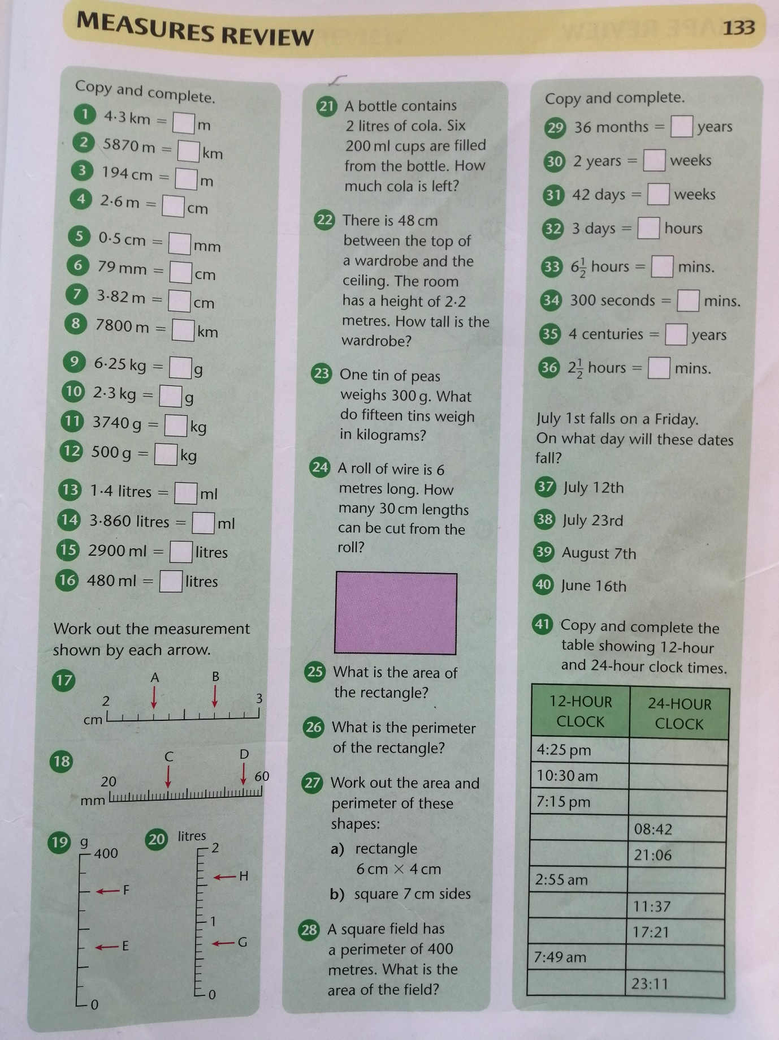

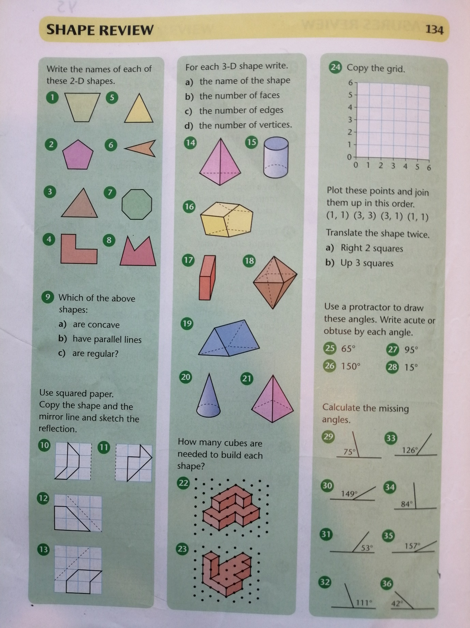
Year 5 mathematics:

Year 6 mathematics:
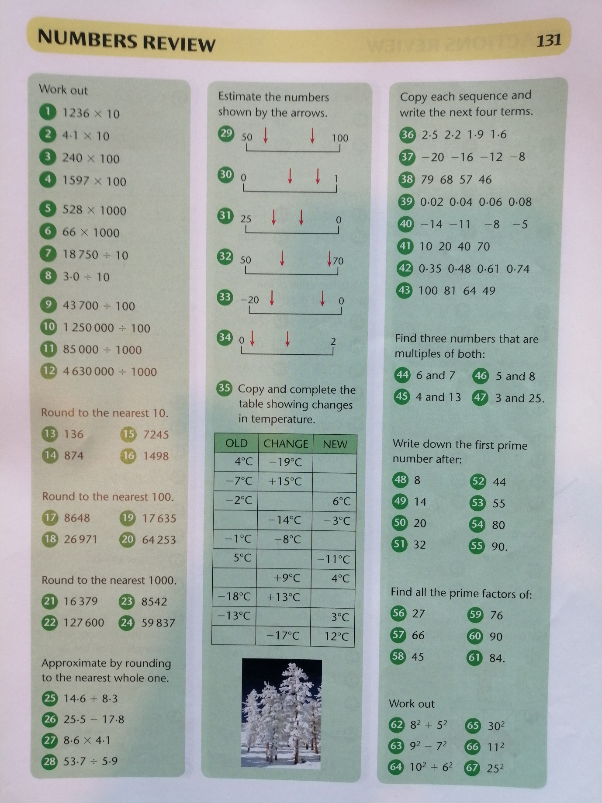

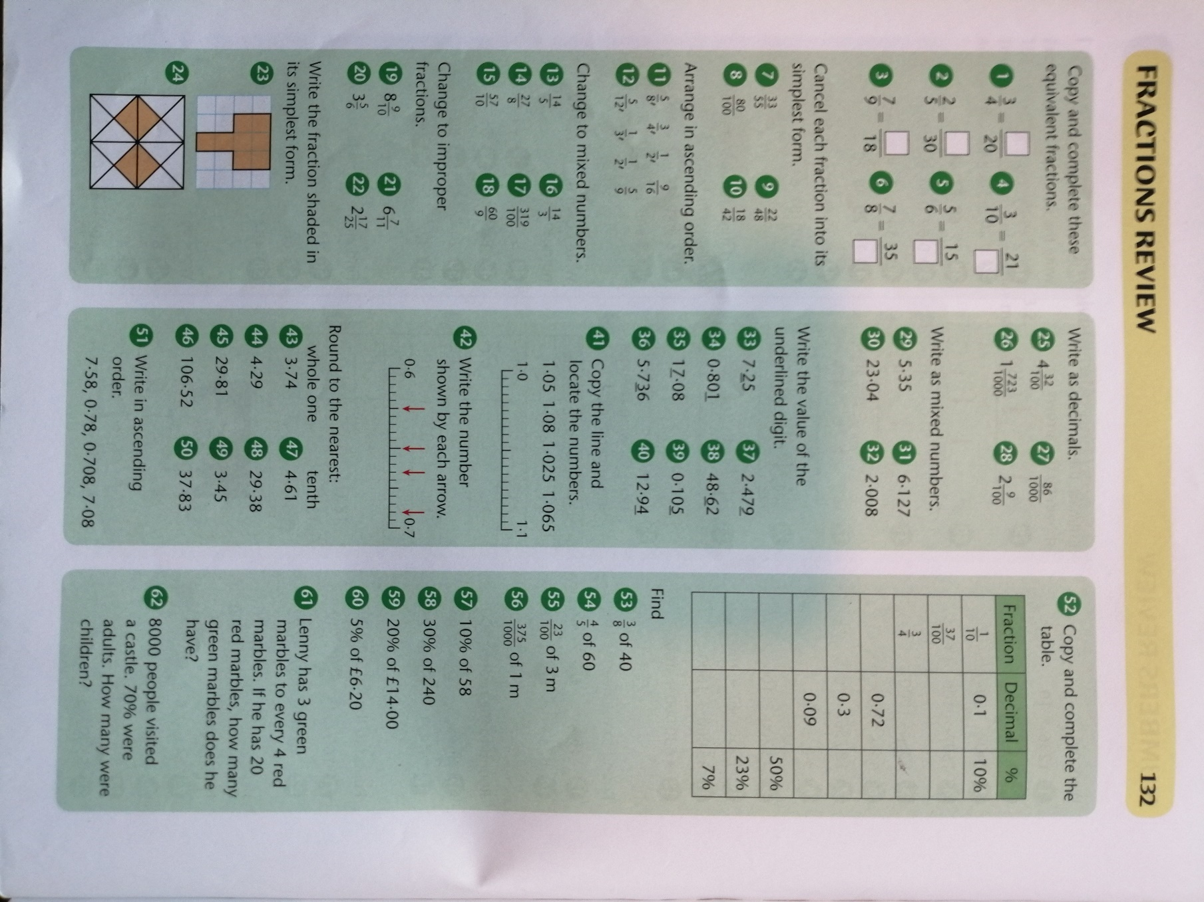
Year 6 mathematics:

Year 6 mathematics:
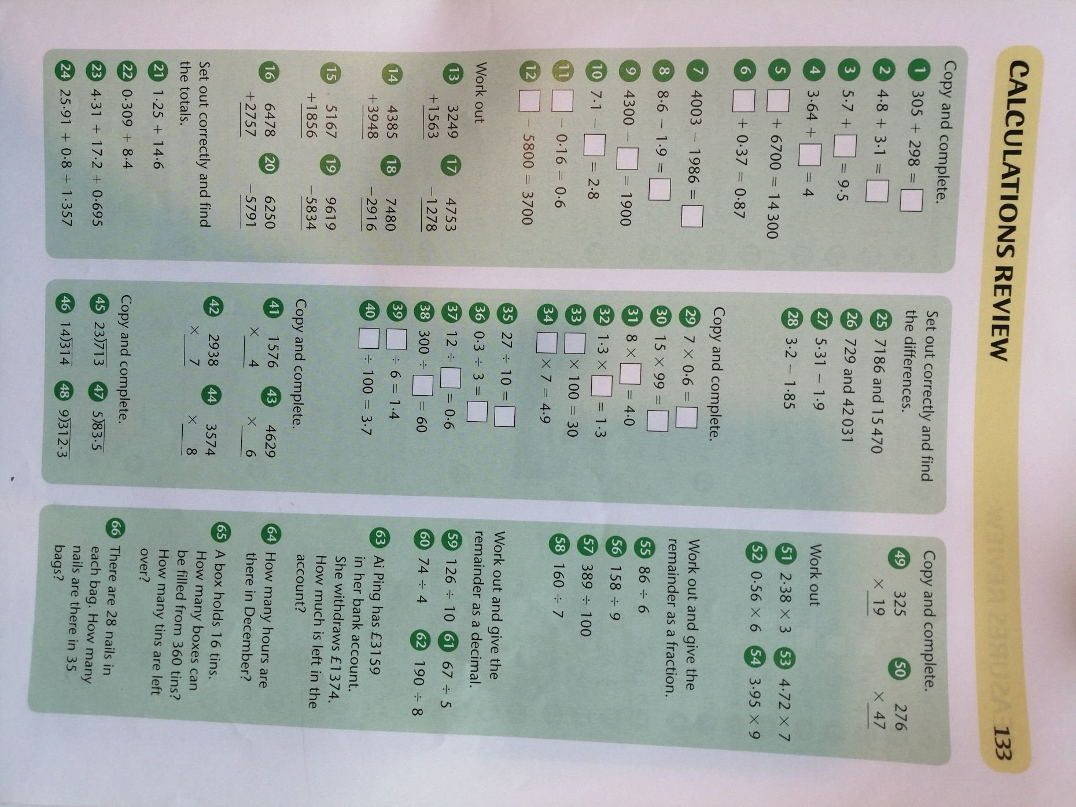
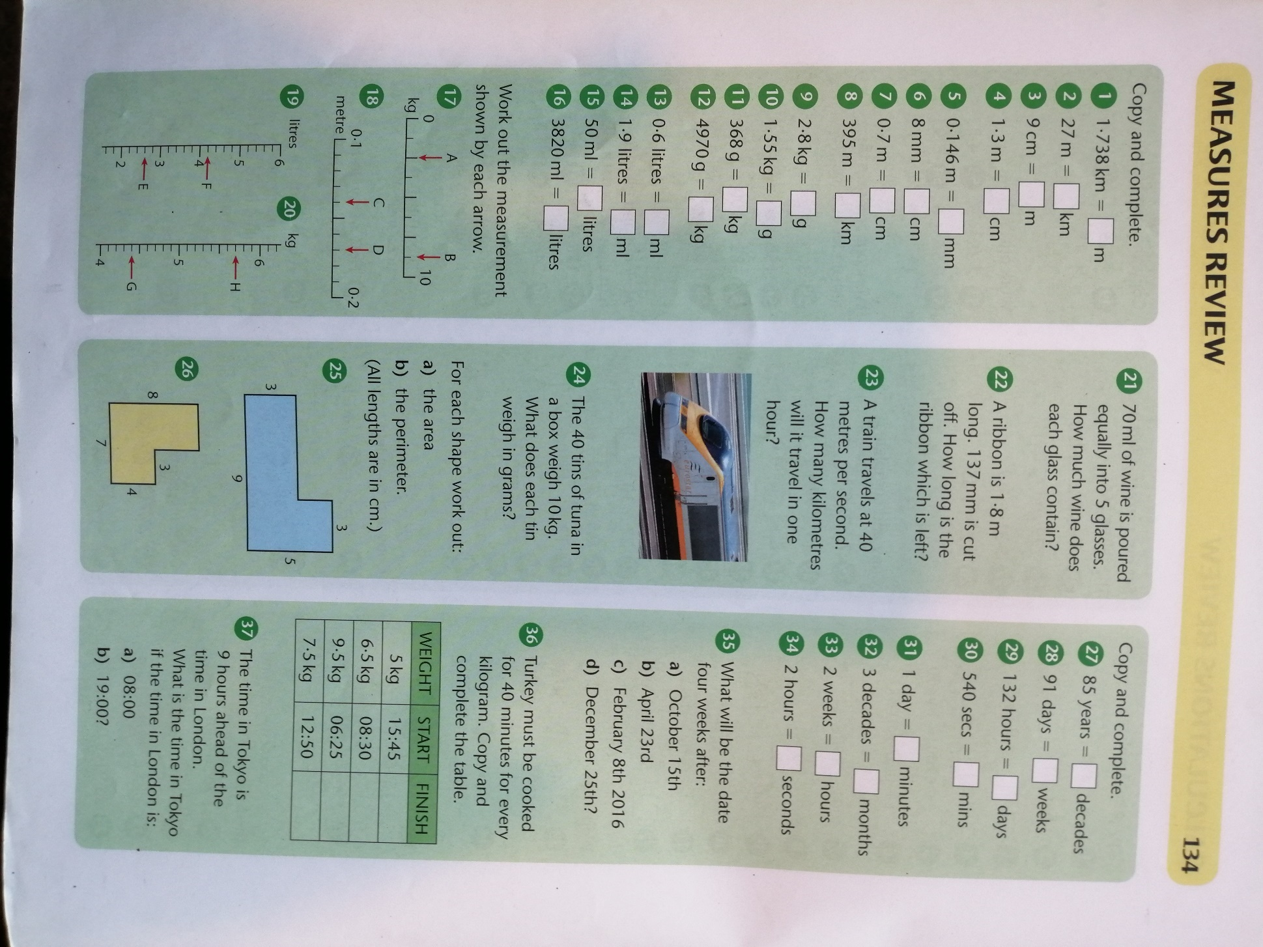
Year 6 mathematics:

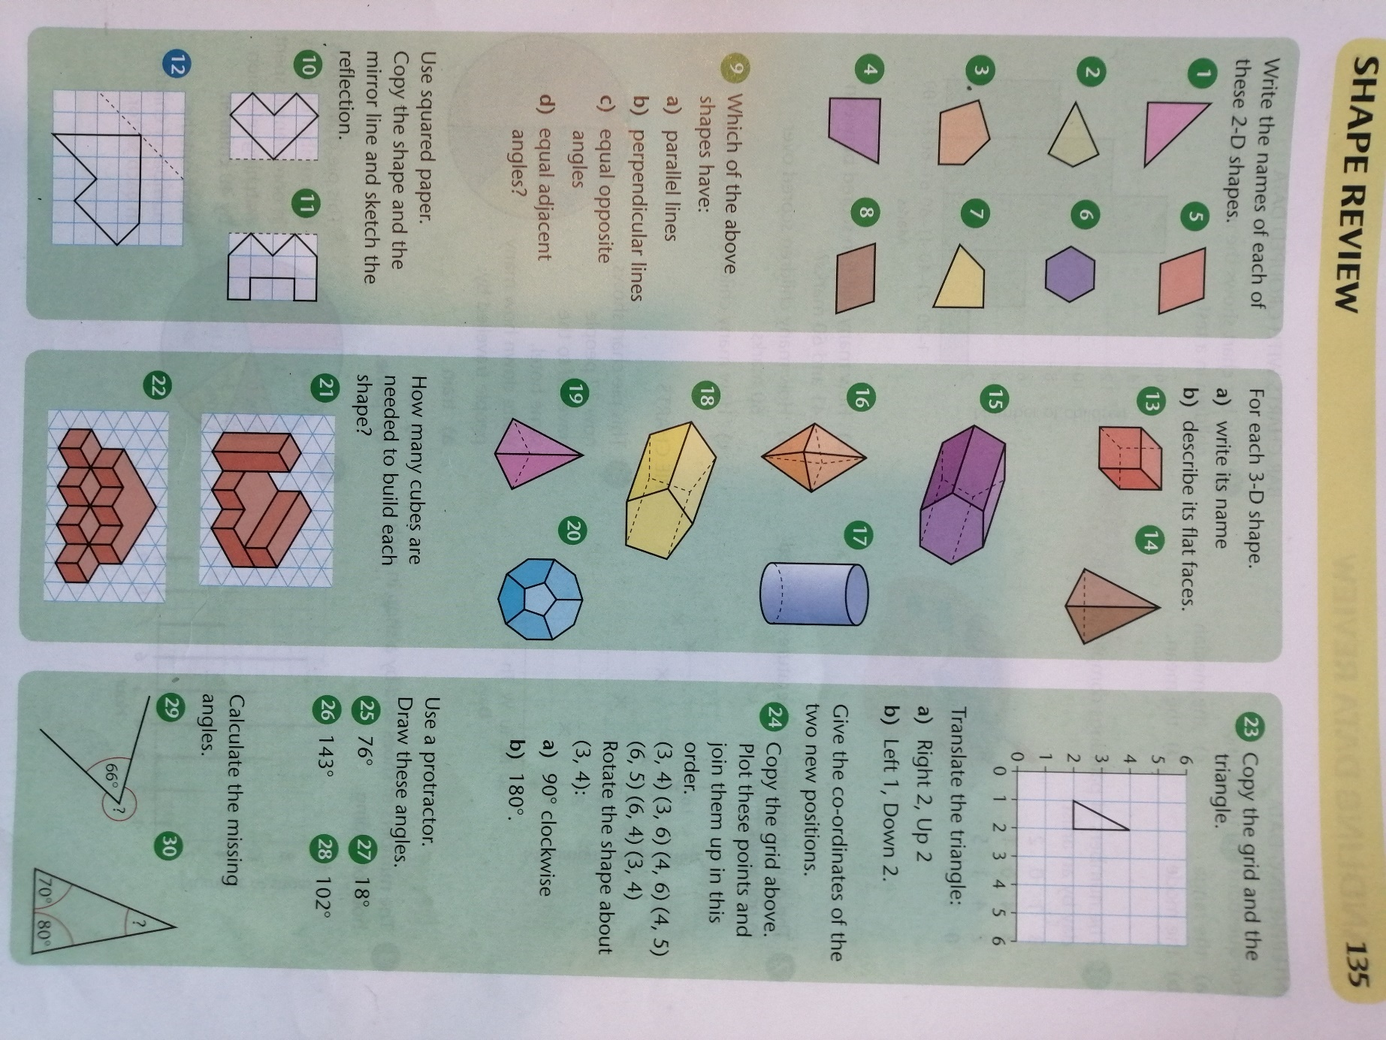
Year 6 mathematics:

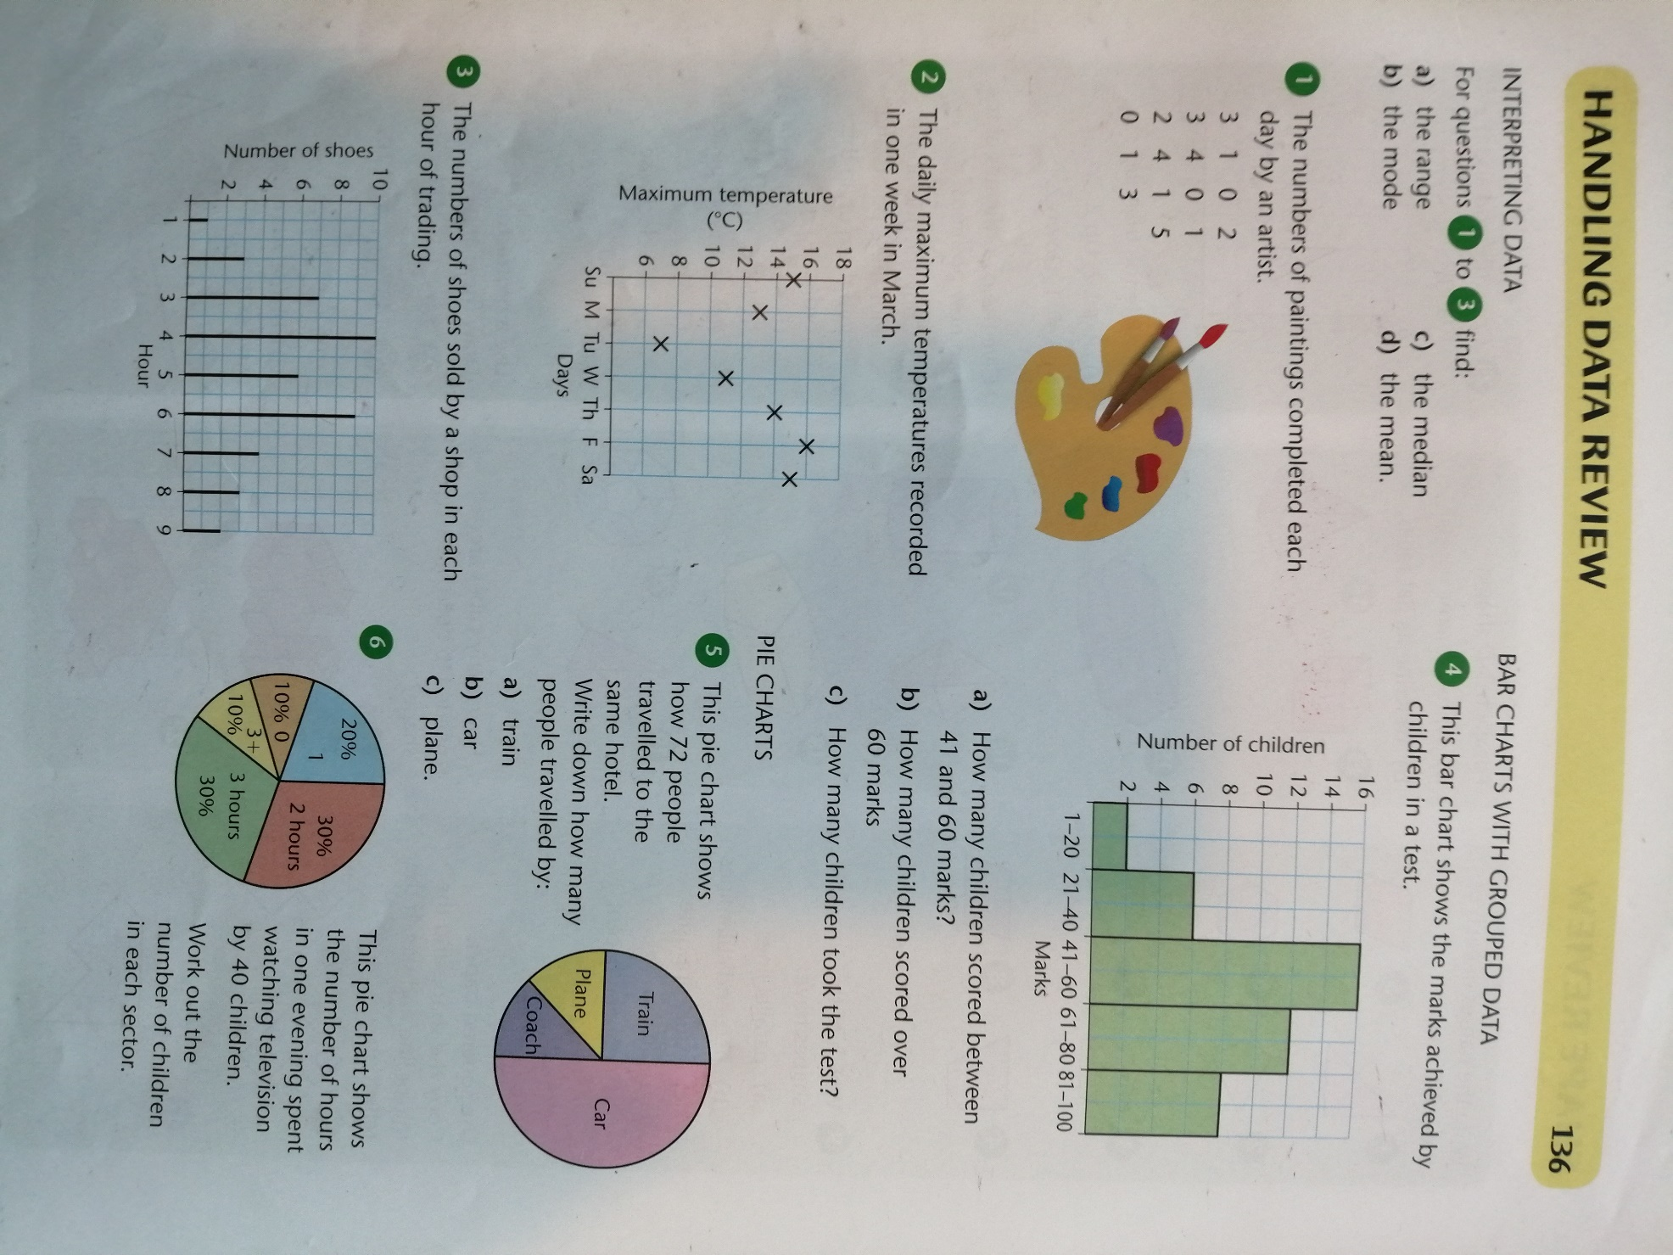
Year 6 mathematics:

Science: For a bit of fun this week, why not have a go at creating your own edible rock? YOU MUST MAKE SURE THAT THERE IS AN ADULT CLOSE BY TO SUPERVISE AND ASSIST YOU!
(Source: https://www.growingajeweledrose.com/2015/02/rock-candy-experiment.html)
Materials (per rock candy colour)
- 2-3 cups of sugar
- 1 cup of water
- Skewers
- A jar or glass
- A large saucepan
- Clothes-pegs
- Food colouring and any sweet flavouring (optional extras)
Method
- Combine equal parts of sugar and water in a saucepan and heat until all of the sugar is dissolved.
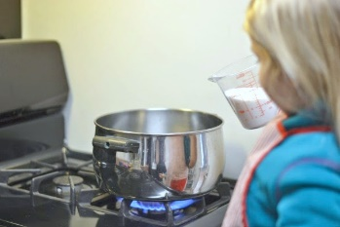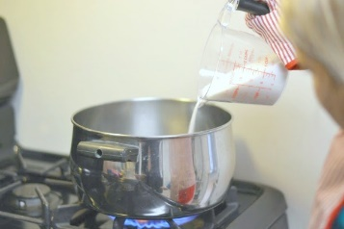
- Then, slowly add more sugar and mix, slowly adding more sugar and mixing until the sugar will no longer dissolve in the water.
- The water should start to look a little cloudy. That is when you know that no more sugar is dissolving, and the perfect sugar-saturation has been reached.
- The short version is that you are creating a saturated sugar solution, or a solution in which no more sugar can dissolve at a particular temperature (like we have done in school when we learnt about the water cycle)
- The amount of sugar verses water used should be roughly 3:1. You can easily double & triple the recipe as long as you maintain a 3:1 ratio.
- Add sweet flavouring if desired, and then continue to heat the water until it comes to a simmer.
- Remove the sugar-water from the heat and allow it to cool.
Preparing the Candy Sticks
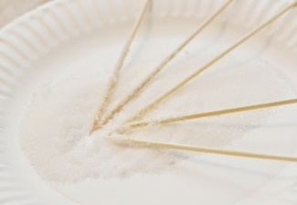
- Cut the skewers to a desirable size for the jar(s) that you are using. Then, dip the sticks in water and roll them in sugar.
- Set the sugar-coated sticks aside and allow them to dry.
Preparing the Jars
- Once your sugar-water is cool enough pour it into jars, using one jar for each colour of rock candy that you wish to make.

- Once the sticks are dry, carefully place them into the jar(s).

- You want to make sure that the sugar-coated sticks are completely dry before placing them in the jars.
- The rock candy needs the sugar on the sticks to grow, and if the sugar isn't dry it will dissolve in the water.
- It is also important to make sure that the sticks are not touching the bottom or sides of the jar.
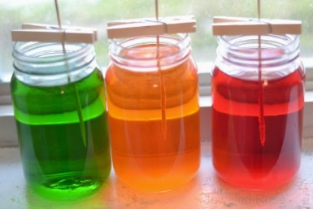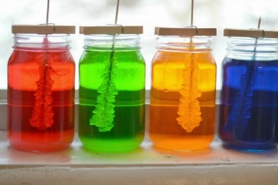
- After a week, your rock candy should be almost ready!
Enjoying Your Rock candy
- After a week, your rock candy can be removed from the jars and enjoyed.
- You can extend the fun and grow your rock candy longer if desired.
- Once you are ready, remove the candy sticks from the jar(s), and then place them on a clean surface to dry.
- Once dry you will have a yummy treat to enjoy!
Want to know more? The Science Behind the Rock Candy Experiment:
- Rock Candy: What's Going On?
- Sugary Secrets: Candy Making Chemistry
- The Sweet Science of Candy Making
History and Design Technology:
Have a go at ‘The Big End of Year Mystery Object Quiz.’ I’m so old that I remember a few of these myself, but it’s interesting to see how quickly technology has advanced.
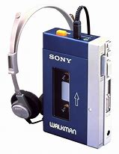
After you have tried the quiz (you’ll probably need to use the internet to search for information), have a go at designing an object/tool that has yet to be invented or is an improvement of what we already have. For example, it’s interesting that when I used to do my paper round (in the last century) I used to imagine having an electronic implant behind my ear and listening to ANY music I wanted – just by thinking the song title! I thought last this would save on buying batteries on for my Sony Walkman because they were really expensive. The electricity from my brain’s synapses would provide the power! This is a Sony Walkman from the 1980’s:
In modern times, you have access to music downloads, voice recognition software and video calls – inventions that were just dreams of the future when I was in Year 5 & 6. What will YOUR children have access to?
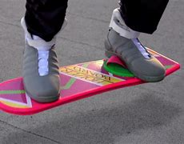


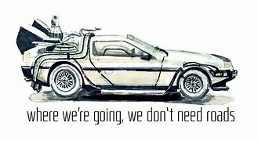
Think of something you’d love to have or could be improve. Does anything do a similar job now? Draw a detailed drawing, including notes and explanations of the design and features. You could even design a poster to advertise your invention!

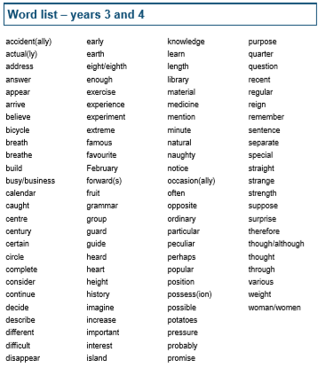
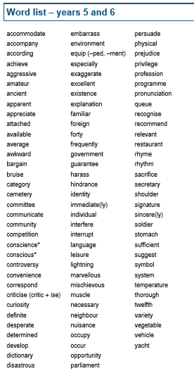
Spellings: As mentioned on the first page, here are full lists of the words for key stage 2.


I hope you all have a super week and enjoy your Summer!
Mr. Smith

