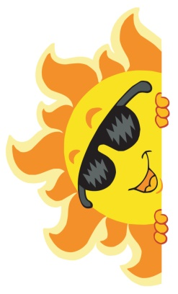
Home Learning for w/c 13th July 2020

Hello Class 3

I can’t quite believe that we are into the last week of the school year; and what a year it has been!

Thank you so much for sending me your lovely messages and pictures of what you have been doing and learning about at home it has been wonderful to see them all. I have spoken to more of you this last week and I have enjoyed hearing all your news and finding out what you have been doing. I have missed you all over the last term.

I hope you enjoy this last week by either looking at some of the activities below or looking back on other weeks and seeing if there are activities that you have not had a chance to complete.

I hope you all have an amazing summer break and we have lots of sunny weather to enjoy being outside. Take care of yourselves and I look forward to seeing you all for the start of the new term.

Mrs Jordan x

https://youtu.be/UWJJC9jMpxs

https://youtu.be/UitSnuLQpw8

Maths

This week why not have a go at some of the maths problems below.
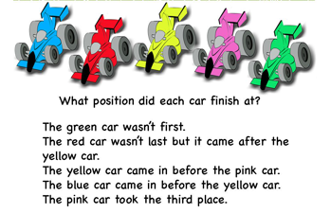
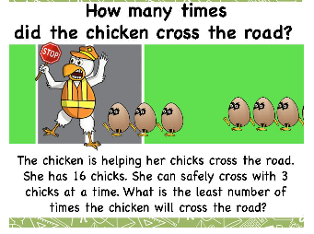

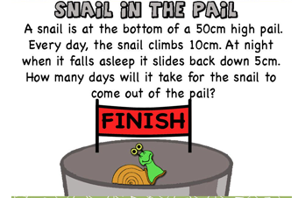

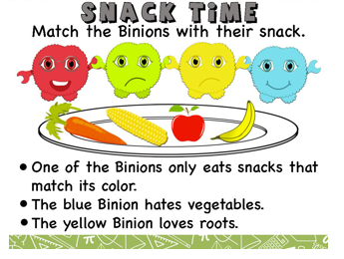

If you want to double check the answers then please look at
mathcurious.com and look in the puzzle section.

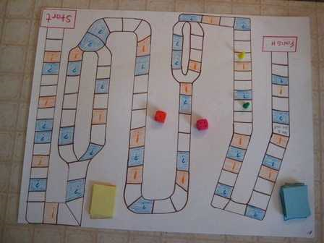
- Can you make your own maths board game? You can use one of the attached templates or design your own. Why not add in sums that you have to answer on the way round, times tables, or word problems? You could link it to a theme or your favourite story.

English

As soon as I heard about this competition I thought of our class straight away and the fantastic plays that you have all written.

Why not write your own play and enter the ‘One Show’ competition. We hope this will help inspire the next generation of playwrights as well as encouraging a love of theatre and the arts in children and young people.
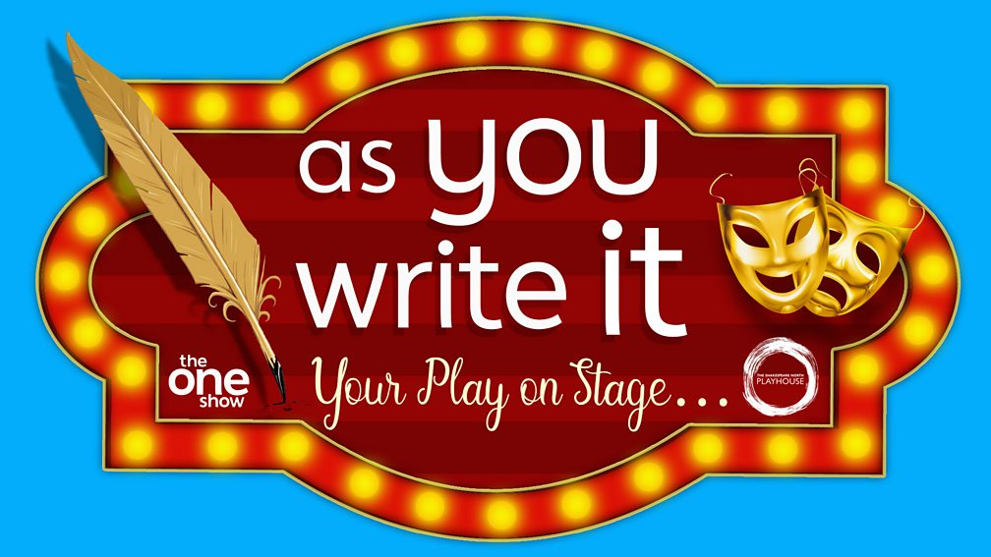

The competition is open to all children and young people aged between 7 and 16 years old. It opens for entries at 7pm on Thursday 25th June 2020. The deadline for entering the competition is just before midnight on Monday 31st August 2020.
All you need to enter is an idea for a play, a short description of up to four of the main characters and the first few opening lines. You’ll also need to tell us what having the opportunity to write your play and have it performed on stage would mean to you.
https://islandartscentre.com/news/bbc-one-the-one-show-as-you-write-it

Another great writing competition is being run by Pearson and is called ‘My Twist on a Tale: Everyday Heroes’.
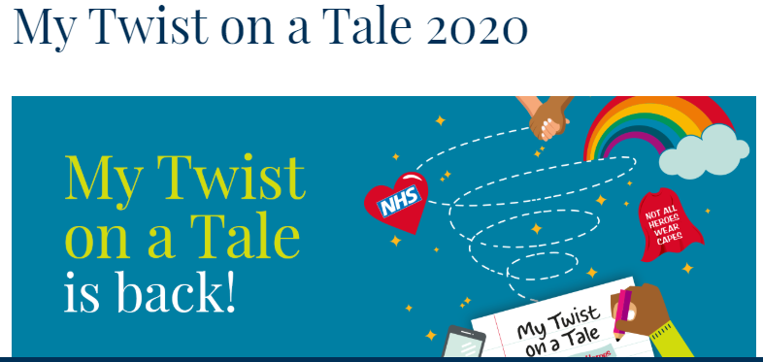

This free competition will encourage four- to 19-year-olds to let their imagination run wild as they put pen to paper and write a story based on an everyday hero.
Following an extraordinary year of disruption, we want to highlight the positive stories that have emerged throughout the year as children write their own tales of local superheroes.
Whether it’s a story about a hero in their local community, a key worker making a difference during the COVID-19 pandemic, a campaigner, a family member or friend that inspires them or even a hero from their imagination, we want children and young people get creative and reflect their own personality, location and experiences as they bring their local crusader to life. And who says the hero needs to be a human? It could be a story about a guide dog or even a cat that comes to save the day.
Entries will need to be submitted online by 17:00 on Friday 27 November 2020, so that the expert judging panel can decide on the winning collection of short stories.

Science

For our very last week I would like you to think about muscles and how we use them, how they allow movement and if we have any pairs of muscles in the body.

https://www.bbc.co.uk/bitesize/topics/z9339j6/articles/zpbxb82

Have a look at the link above and the attached power point all about mighty muscles.

Can you make a prediction about what muscles you think you will need to run, skip, read a book, do a star jump or lift something from the floor? Have a go at the activity and then see if your predictions were correct. There is an activity sheet provided if you think you need it.

Theme / – Vikings

When the Vikings had some spare time they spent it doing things they loved. Viking men enjoyed swimming, wrestling and horse racing. In winter they skated on the frozen lakes and skied on the snow. Their favourite board game was Hnefatafl (kings table). This is similar to draughts and chess. Children played football, sailed model boats and had wooden dolls. Vikings are thought to have used animal bones to make games and toys.
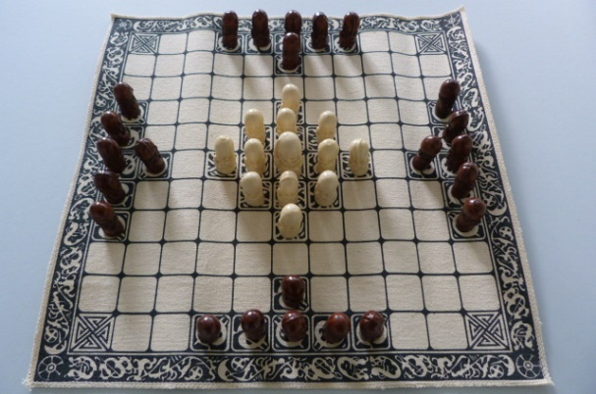
Have a look at the link below which is a board game example from English Heritage.
https://www.english-heritage.org.uk/members-area/kids/anglo-saxon-england/hnefatafl-viking-board-game/

An alternative activity would be to make some Viking bread.
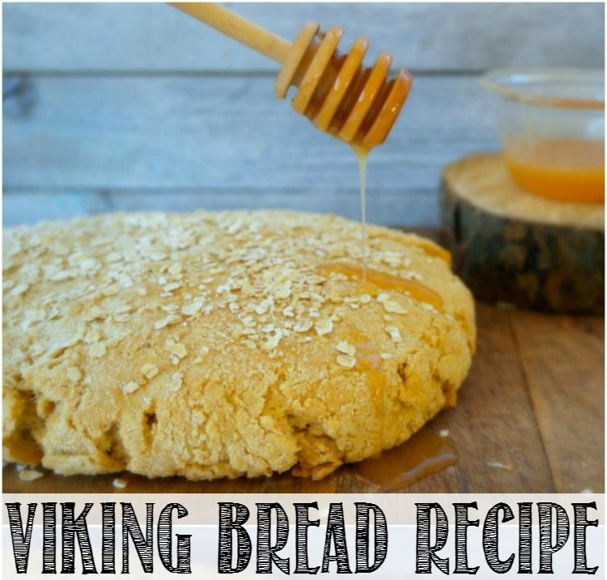

This is a heavy bread, most likely what you read about when you come across references to “brown bread” in history or historical fiction books. While I wouldn’t recommend it as a substitute for your Italian or sourdough dinner bread, it was really good as a snack – warm from the oven and drizzled with honey

https://raisinglifelonglearners.com/kids-in-the-kitchen-viking-bread-recipe-2/

PE

- In the classroom we have been enjoying Cosmic Yoga in a morning or alternatively Andy’s Wild Workouts, they have really got us going in a morning and ready for work.

General

- Why not have a go at the big end of year picture quiz – can you guess what the items are?
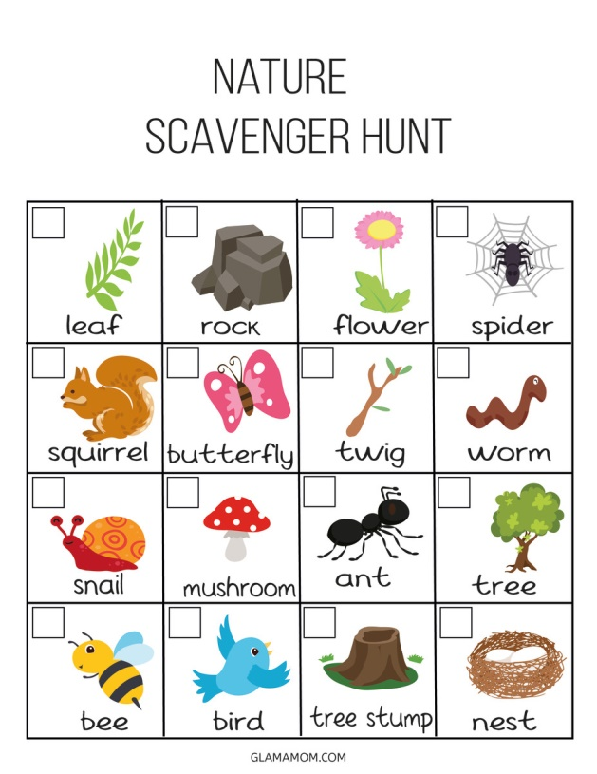
- Remember there are still a few days left to get your entries in for the FOSS competitions; I can’t wait to see your entries.
- Why not do a summer or nature scavenger hunt, you could do this in the garden or whilst out on a walk. Maybe you could make on for a brother or sister.
- Make a butterfly feeder from items you will have around the house, follow the link from the RSPCA
https://www.rspca.org.uk/-/butterfly_feeder
- Can you blow giant bubbles? Have a look on the science museum website and have a go.
- https://www.sciencemuseum.org.uk/see-and-do/bubbles-bubbles-bubbles

