CLASS 2 Home Learning for w/c 13.7.20

I cannot believe that it is the last week of term! I hope that you are all looking forward to the summer break. This week in class we have been busy with solving problems in maths, practising lots of different skills to break the codes. We have enjoyed our writing based on the Highway Rat story by Julia Donaldson, coming up with some brilliant wanted posters, some creative alternative hero endings and apology letters. We have done quite a lot of science this week too as well as getting creative!
This week I am stripping the home learning back as I hear from a few parents that there have been more tasks than you have been getting through recently – if there is anything that you have not had chance to get done then you can go back and find some ideas if you want to. I have given some ideas for open ended tasks that would make nice little projects and there are some links for summer holiday activity ideas, again if needed.
I really hope that everyone has a fantastic summer holiday (and that the weather goes back to being sunny again!) - I am very much looking forward to seeing everyone back in school from September.
Mr Cash.

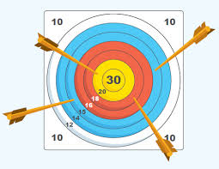
Maths

To bring together your maths learning could you have a go at creating your own maths game?

Maybe it could be like one of the games that we play in class.

Maybe it could be a maths board game that you design and make.

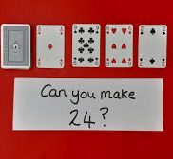

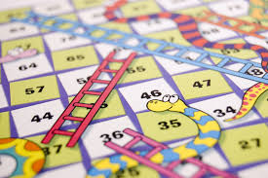

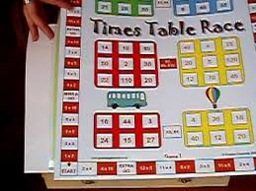

English

For all of you that want to keep on having a go at your creative writing, there are some fantastic and inspiring pictures at https://www.onceuponapicture.co.uk/ and also at https://www.pobble365.com/ that you can use for ideas if you need them.

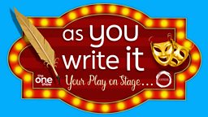
If there are any budding playwrights out there then the BBC One Show have a competition, that has a closing date of 31st August, called ‘as you write it – your play on stage’. You could get your own play written and performed on stage!!

From the website – ‘All you need to enter is an idea for a play, a short description of up to four of the main characters and the first few opening lines. You’ll also need to tell us what having the opportunity to write your play and have it performed on stage would mean to you.’
The competition is open to 7 – 16 year olds in 3 different age categories, get all the details here: https://www.bbc.co.uk/programmes/articles/1SCKS8VmFFGvyggKbqGGyds/as-you-write-it-your-play-on-stage
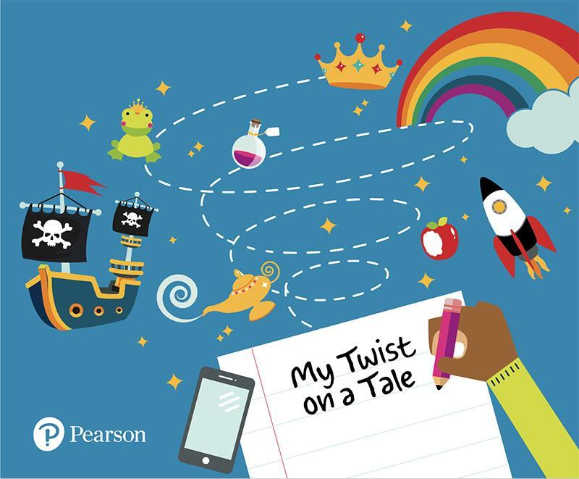
Another writing competition is being run by Pearson and is called ‘My Twist on a Tale: Everyday Heroes.’

This free competition will encourage 4 to 19-year-olds to let their imagination run wild as they put pen to paper and write a story based on an everyday hero.

Following an extraordinary year of disruption, Pearson want to highlight the positive stories that have emerged throughout the year as children write their own tales of local superheroes.

Whether it’s a story about a hero in their local community, a key worker making a difference during the COVID-19 pandemic, a campaigner, a family member or friend that inspires them or even a hero from their imagination, they want children and young people get creative and reflect their own personality, location and experiences as they bring their local crusader to life. And who says the hero needs to be a human? It could be a story about a guide dog or even a cat that comes to save the day.

Entries will need to be submitted online by 17:00 on Friday 27 November 2020 (so plenty of time to get ahead of the game!), so that the expert judging panel can decide on the winning collection of short stories. Full details here: https://www.pearson.com/uk/educators/schools/subject-area/literacy-and-english/EngagingReadersandInspiringWriters/my-twist-on-a-tale-competition.html

Competition Time: DON’T FORGET THE FOSS COMPETITIONS If YOU HAVEN’T ALREADY! – the ‘Decorate a Duck’ and ‘Family Challenge’ deadline is fast approaching!

DT/Art: Grab yourself some googly eyes and some bright coloured paper and get creative with characters or crafting – summer has inspiration for art everywhere!

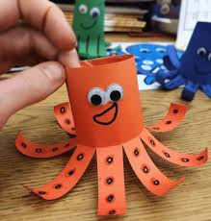 | 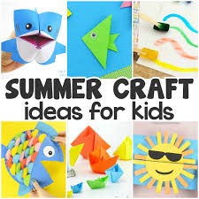
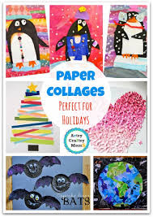 | 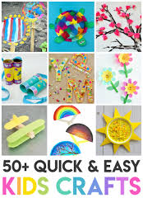

See the school newsletter from last week for details of the North Yorkshire County Council ‘Sustainable Travel Art competition’ as well as the entry form.

Science: It was good to see some example of the rainbow experiment you had been trying.

There are so many fun science projects and ideas that you could try over the summer holidays it is difficult to know where to start. I know when I was younger, I used to enjoy changing the colour of flowers and lettuce using food dyes, trying to grow salt crystals, making my own slime (sometimes with glitter!!), I used to enjoy launching water rockets and experimenting with bubbles – especially a bubble cube! Great fun.

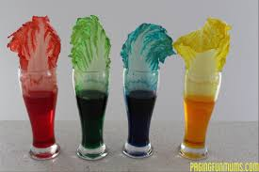 | 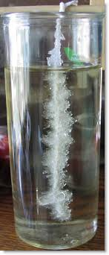
 | 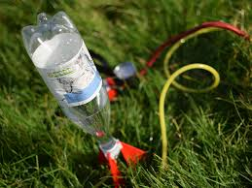
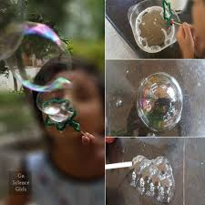 | 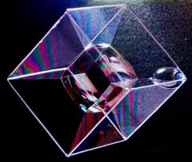
Other ideas: https://funlearningforkids.com/summer-science-experiments-stem-activities/

https://www.growingajeweledrose.com/2013/05/science-fun-for-kids.html

PSCHE: Listen to the song ‘Proud’ by Heather Small https://www.youtube.com/watch?v=-4szP49_HKE

Can you try and do something everyday to make you feel proud? A tough challenge I know but you can be proud of small things as well as bigger things!

French: Can you draw a poster for a day on the beach (or another summer scence) and label all the things in French?

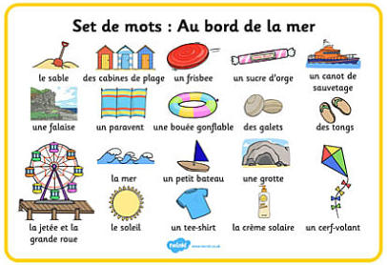

Other Activities
  - Joe Wicks is only going to be live on Monday, Wednesday and Saturday this week and will be doing his last live session on Wednesday 22nd July – we have been doing Joe’s sessions everyday in my bubble and have enjoyed getting moving each morning!
You can still access all the old PE sessions though so no excuse for not getting some daily movement in your life!
https://www.youtube.com/playlist?list=PLyCLoPd4VxBvQafyve889qVcPxYEjdSTl

  - The 100 things to do at home ideas from the Scouts, will hopefully continue to provide ideas for things to do if you need some indoor ideas.

  - Keep adding to your nature diary – summer is an amazing time to see different birds, insects and mammals, especially swifts swooping around in the fields, beautiful butterflies, dragonflies, the occasional kingfisher by the water (though they move very fast!) and the shy Fallow deer if you are lucky. If you head to the beach then look out for crabs and starfish in the rockpools.

  - Blue Peter have started their ‘6 Badges of summer’, every week there will be a different theme to the badges ranging from sport, to helping save the environment, music, thank you as well as a final silver badge. You can download a wall chart to keep track of how you're doing and you can even apply for the badges themselves. There is definitely something for everyone so have a look and get stuck in! - https://www.bbc.co.uk/cbbc/joinin/six-badges-of-summer

