Home Learning for w/c 6th July 2020
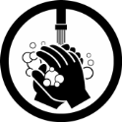
Hello Class 3

It has been lovely to speak too many of you on the telephone this week and for those that I have not yet spoken to, your call is coming!

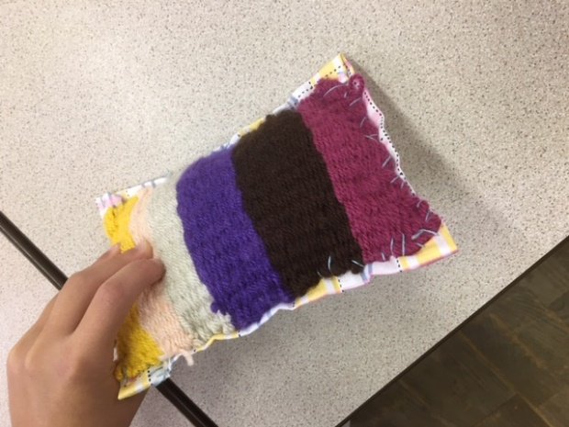
I have seen some fantastic Viking shields as well as weaving; the picture below is from someone that has turned their weaving into a little pillow ready for the arrival of a new kitten.

Remember to look at the fantastic activities that FOSS have organised, I look forward to seeing some of the designs.

I have heard from you about so many activities you have completed and it has reminded me about how amazing you all are and how very proud I am; of all of you! I hope you all have another good week, stay safe and look after each other.
Mrs Jordan

https://youtu.be/SH3Ef7nmwSc

https://youtu.be/9VAkmYEy3mI

Maths

Remember to continue to practice your times tables, why not play some of the games on ‘top marks’ or have a go at completing a times table square and time yourself, can you get quicker.
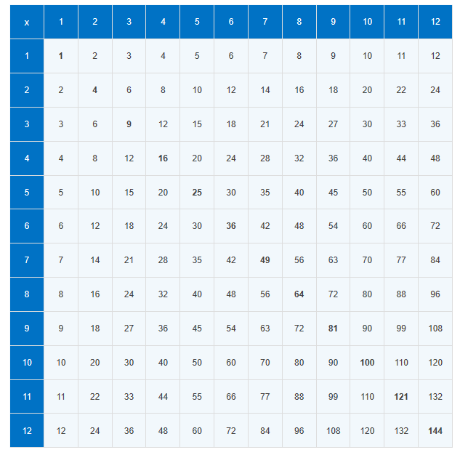

This week the focus is on addition and subtraction problem solving.

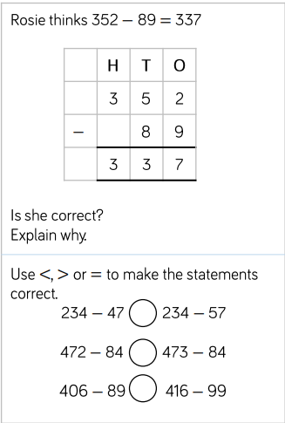
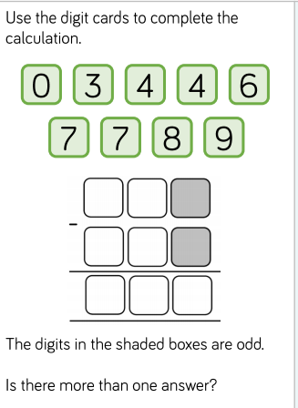

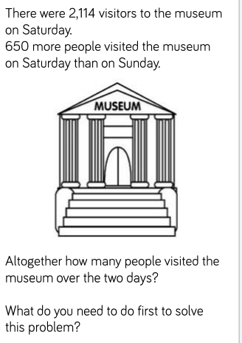
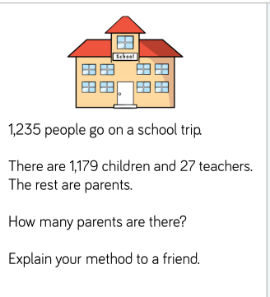

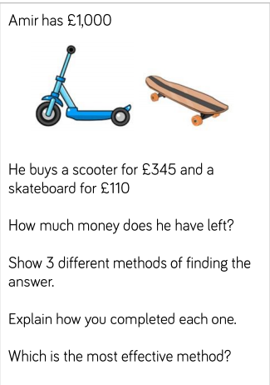

English

- Can you have a go at completing the SPAG mat number 6 for both year 3 and year 4?
- Attached is a reading comprehension for you to try all about Captain Tom Moore and what he has achieved over the last few months.
- Using the comic strip template provided can you create your own short story, this could be based on a story you have recently read and you could change the human characters to animals or it could be based on a traditional tale. You could change the characters or the setting.

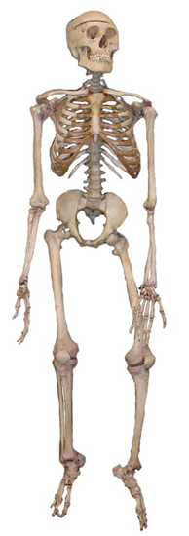
Science

This week in science we are moving onto looking at skeletons and bones. Different animals have different skeletons.

- Can you find an example of an animal that would have the following skeletons?

- Endoskeleton
- Exoskeleton
- Hydrostatic skeleton

- Can you find out what the functions of the skeleton are?
- Can you label the main bones in the human body using the correct names?
- Have a look at the power point and see if you can guess which part of the body the X-ray has been taken of.
- Using the template can you make yourself a split pin skeleton?

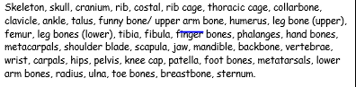

https://www.bbc.co.uk/bitesize/clips/ztfnvcw

Theme / – Vikings

The Vikings built their houses from local material such as wood, stone or blocks of turf. They lived in long rectangular houses made with upright timbers (wood). The walls were made of wattle (woven sticks, covered with mud to keep out the wind and rain). Viking houses were often one room homes with a cooking fire in the middle. The smoke escaped through a hole in the roof

https://primaryfacts.com/5593/viking-homes-and-houses-facts-about-viking-longhouses/

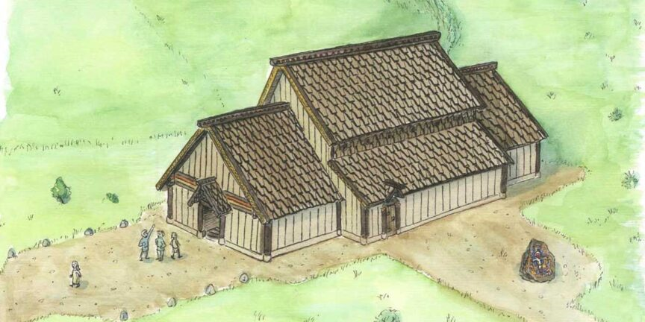

https://www.bbc.co.uk/bitesize/clips/zrthfg8

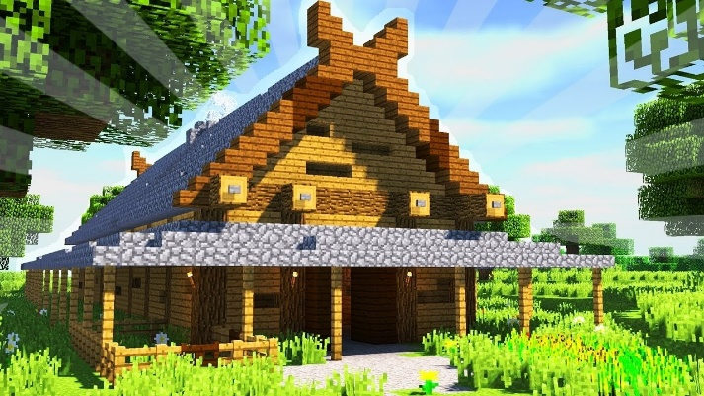
- For your activity you could draw and label a long house, make one using Minecraft or use the template to create your own and maybe make a Viking house small world.
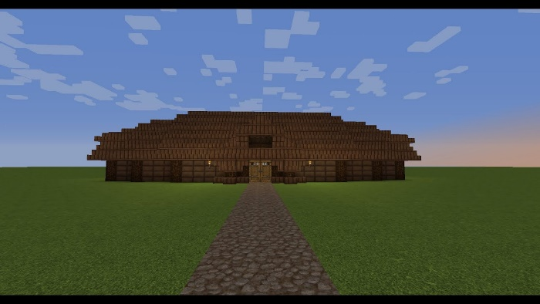
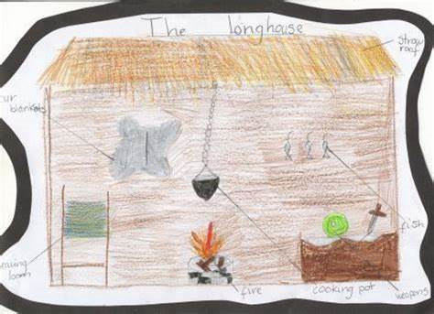
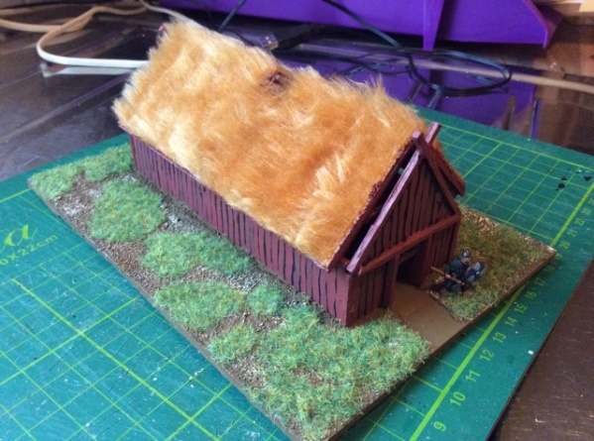

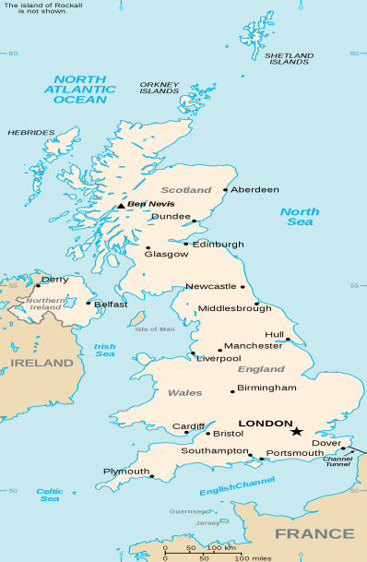
Geography

Why not take the time this week to learn more about another area in the UK. Can you find a map of the UK and confidently know the four countries and major cities? Do you know where London, Edinburgh, Manchester, Birmingham etc. are located?

- Choose another city or town where you maybe have friends of family and find out where it is located; what are some of the features of the town? Also can you find out about some topographical features including hills, mountains, rivers and see how the place has changed over time.

General

Why not try using semaphore?
Semaphore is a way to signal the alphabet using two flags, one held in each hand.
To send a message, your left and right hands have to be in two different positions. You start with both hands pointing down. You could start by making some flags and then sending messages.
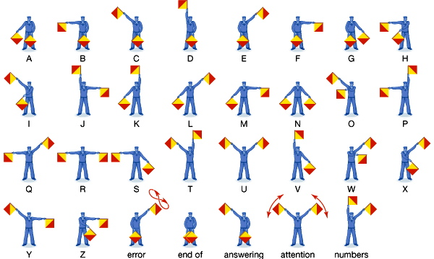
Here are the signals for the letters of the alphabet:

