CLASS 2 Home Learning for w/c 6.7.20

What a change there has been this week in the weather! It hasn’t felt very much like summer but I know that the vegetable patch in my garden is very much enjoying it.
In school this week, my bubble has enjoyed the maths problem solving activities (especially the coloured cube problem and the extension which has really tested the trial and improvement method – and patience!!). We also enjoyed exploring different techniques in poetry writing – wishing the sun would come back out with our words on the page. In science the skittles experiment was brilliant and we altered variables such as the temperature and the amount of water to see what the effect would be. Everyone has been learning the ‘Bring the noise’ song and the singing and actions got louder and bolder as the week went on – good fun! I hope that everyone is keeping safe and well – it seems like such a long time since I have seen you all. Take care and keep safe.
Mr Cash.

Maths
This week I would like us to carry on our practical problem-solving skills and reasoning as a consolidation of all the different skills that we have learned over the year so far.

Notes:

‘The national curriculum for mathematics aims to ensure that all pupils:
‘Can solve problems by applying their mathematics to a variety of routine and non-routine problems with increasing sophistication, including breaking down problems into a series of simpler steps and persevering in seeking solutions.’
Remember: 'having a go' is a great way to make a start on a mathematical problem. Whatever happens, you will have learnt more about the situation and can then tweak your approach. This is known as the 'trial and improvement' way of working.
It would be useful to be able to print the attached sheets, but if you are not able to then you can still solve the problems by working through the clues on the screen.

Activity 1: The Mystery Daytime Feather (see attached pdf)
Otis Owl has been learning about daytime birds and has the challenge to work out which type of daytime bird a feather belongs to. Can you help Otis, working through the different clues, to work out who the mystery feather belongs to?
Use your greater than/smaller than, fractions, addition and multiples of 5 knowledge to help you.
Activity 2: The Mystery of the Naughty Gnome in the Gnome Valley (see attached pdf)
Something has been going on in the usually happy community of gnomes, there have been strange things happening. There has been a theft of gnome fishing rods, the ‘Welcome to Gnome Valley’ sign was hidden and uniforms have been vandalised! Can you help detective gnome solve the problems to see which naughty gnome has been u to no good?
Use your statistics, symmetry, addition, subtraction, multiplication, division, double/half and code breaking skills to help you.
Activity 3: The Mystery of Zone A at the Aquarium (see attached pdf)
Work through the different clues to find out the ‘culprit’ and cross them off the class list – someone has messed with the display signs at the aquarium - can you find out who dunnit?!
Use your division, multiplication, addition, subtraction, sequencing, greater than/smaller than, fractions and statistics skills to help you.
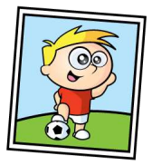
Activity 4: Can you have a go at these reasoning and problem-solving questions?
- Razza and Gina have the same number of stickers.
• Razza gives 15 stickers away.
• Gina gives 32 stickers away.
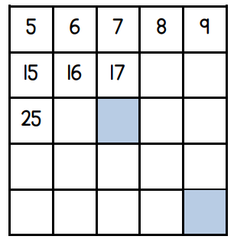
How many more stickers than Gina does Razza have now?

- Here is part of a number square.

Add together the two numbers that would be in the shaded squares.

- Choose one of these symbols <, > or = to make the number sentences correct.
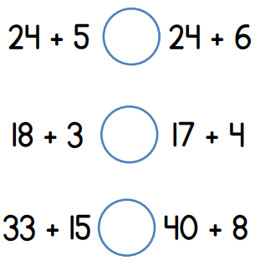

Here are some digit cards. Meg and Sam each use two of the cards to make a number. What is the difference between their two numbers?
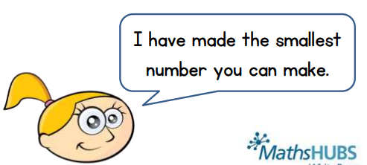

Can you create a largest / smallest number problem yourself using 3 digit cards – you could maybe try making the largest / smallest number using all 3 cards instead of 2 and finding the difference?!

Extension: CHALLENGE YOURSELF!!

Here is a balance scale.

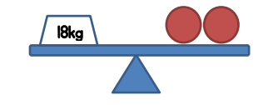

Here is another balance scale.

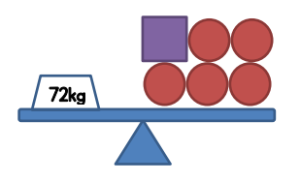

Can you work out the weight of two s

Mental Maths:

Don’t forget to be practising your mental maths skills!!

Use the games such as Hit the Button at https://www.topmarks.co.uk/maths-games/hit-the-button to practise your number bonds, times tables and doubles/halves etc.

If you have digit cards or dice you can choose two cards or roll your 2 dice. Then quickly add them together, work out the number bond to 20 as quickly as you can or multiply the numbers together.

Ask a parent or carer to write a number sentence for each of the four operations + - x and ÷ and have a go at solving them – don’t forget to use the practical resources if it helps.

English
I have been very impressed with some of the summer poems that you have sent in for me to look at. Some excellent examples of rhyme and creative use of language, well done.

Reading: Can you share a story with a parent or a sibling each day this week? It is wonderful to read out loud and you can really use your voice to bring the words to life.
To listen to a story you can access hundreds of books FOR FREE on Audible here: https://stories.audible.com/start-listen

Reading comprehension: During the story reading or listening above, use questions starting with ‘who, what, where, when, how and why’ to allow them to explain what they are reading or listening to. I like to get them to describe what they can see in their heads at various point using ‘I wonder what that would look like…?’. There are also some really good reading and phonics games on the Oxford Owl website.

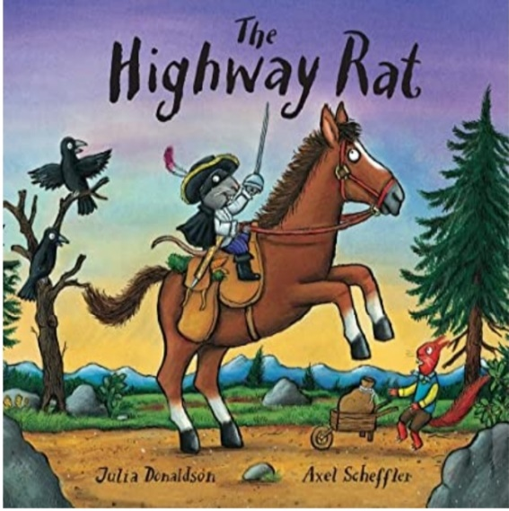
Writing:

If you have the book, have a read through the story of the Highway Rat by Julia Donaldson – if you do not have the book then you can watch the animation of the story on BBC iplayer here: https://www.bbc.co.uk/iplayer/episode/b09kkt1k/the-highway-rat

Activities Choose (or do them all!) from the below:

- In the story, the Highway Rat steals from others around him. Can you make a wanted poster for the Highway Rat, listing his name, what he looks like and his crimes?

In our bubble we really enjoyed creating a wanted poster for Mr Wolf when we were thinking about the picture – I hope you enjoy making one too.

- At the end of the story, the cunning duck becomes the hero of the story by saving the day. If you were the hero in the story, what would you do to stop the Highway Rat from stealing? How would you help?

- The Highway Rat finally gets caught out for his unkind acts towards others. Can you use your journalist skills to make a newspaper report about the moment he is caught out and what happens to him?

- Can you write an apology letter from the Highway Rat to the other animals that he stole from to say sorry for what he had done and ask for their forgiveness?

SPAG: I know a few parents have been asking for a little more information on expectations in some aspects of the curriculum. SPaG stands for Spelling, Punctuation and Grammar and is a core focus of the English National Curriculum released in 2014.The below is taken from the 2014 National Curriculum.

What do KS1 Children Need to Learn in their SPaG and Vocabulary Lessons?

In Year 1, children are taught how to:

- Leave spaces between words in sentences.
- Join words and clauses up.
- Begin to punctuate sentences using capital letters, full stops, question marks and exclamation marks.
- Use capital letters for names of people, places, days of the week and the personal pronoun ‘I’.
In Year 2, children are taught how to:

- Use familiar and new punctuation correctly, which include commas and apostrophes.
- Write sentences with different purposes: statements, questions, exclamation and command.
- Expand noun phrases to describe.
- Use present and past tenses correctly and consistently.

Activity:

I have attached a practise activity called Popping Punctuation.

Can you work through the activities using the hints in the balloons to help you?

You could print out the sheets but if that is not possible then copy out the sentences and circle the punctuation or changes you have made. (DON’T LOOK AT THE ANSWER PAGES UNTIL YOU HAVE FINISHED!!)

Other

There are some excellent spelling and grammar games on the brilliant Topmarks website suitable for year 1 and 2 https://www.topmarks.co.uk/english-games/5-7-years/words-and-spelling

Phonics (Year 1): If you want to be able to practice phonics then there is a fantastic resource on YouTube being introduced from 27/4 focussing on learning for the summer term with daily lessons being added. You can find the channel called ‘Letters and Sounds for Home and School’ in association with the DfE here https://www.youtube.com/channel/UCP_FbjYUP_UtldV2K_-niWw/featured?disable_polymer=1.

Reading: Can you share a story with a parent or a sibling each day this week? It is wonderful to read out loud and you can really use your voice to bring the words to life.
To listen to a story you can access hundreds of books FOR FREE on Audible here: https://stories.audible.com/start-listen

Competition Time: DON’T FORGET THE FOSS COMPETITIONS IS YOU HAVEN’T ALREADY! – the ‘Decorate a Duck’ and ‘Family Challenge’.

DT/Art:
Continuing on our summer and coloured themed art challenges – I wonder if you (or anyone else in your family) has a pile of old magazines that you can cut up in to coloured pieces, from the picture, and use these to make a collage picture?

Below are some examples that I really like:

 | 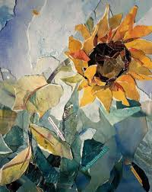
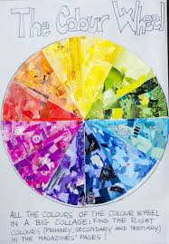 | 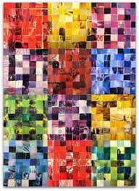

Science:
We really enjoyed having another go at the Skittles activity in class – I hope you did.

How to Grow a Rainbow Science Experiment

Did you know that you can grow your own rainbow? You will need a scientific process called the capillary action. This action happens when a liquid moves up through a hollow tube or into a spongy, solid material. It happens when three forces work together: cohesion, adhesion and surface tension. Water molecules like to stick to each other - this is called cohesion. They also like to stick to solids in a process called adhesion. In this experiment, you are going to use kitchen roll. The fibres in kitchen roll have lots of little holes. Water is absorbed through the kitchen roll because when the first water molecule adheres to it and begins to move upward, it pulls the next water molecule up with it, like a chain.

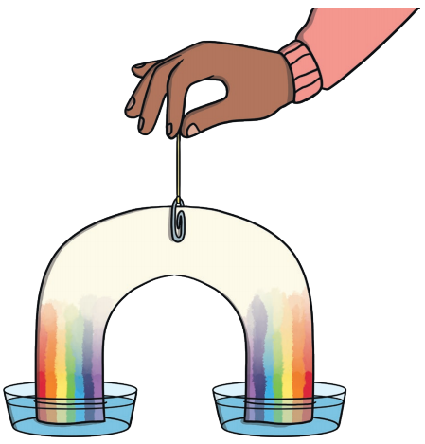 | 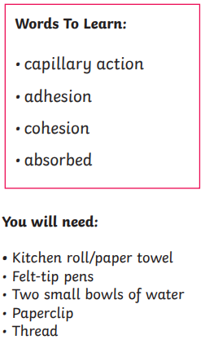

What To Do:
1. Cut the kitchen roll into the shape of a rainbow.
2. At each end, use the felt-tip pens to colour a rainbow about 2cm up from the bottom. Remember the order of the colours: red, orange, yellow, green, blue, indigo, violet.
3. Attach the paperclip to the top of the rainbow and tie a piece of thread to it. This will allow you to hold your rainbow.
4. Add water to the two bowls.
5. Hold the rainbow with both ends slightly submerged into each bowl of water and watch your rainbow grow.

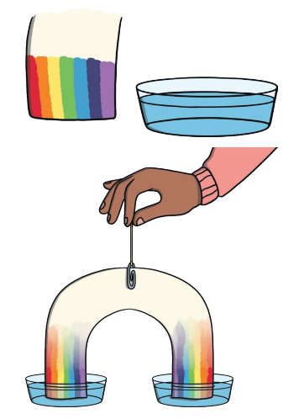

Theme:
As the end of our space theme approaches, I was wondering if you could get your hands on an old shoe box and create a space related diorama – a model representing a scene in 3D? Maybe you could create a 3D spaceship scene? Maybe you could create a 3D rocket launch scene? Maybe you could bring your ideas for an alien planet to life in 3D? What about a space exploration scene or a trip to the moon (bring the craters to life in your 3D modelling)?

Some ideas that I have seen are:

 | 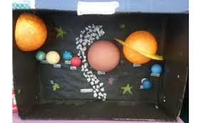
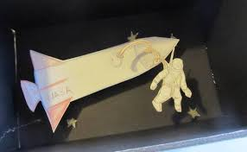 | 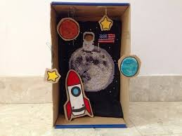

PSCHE:
Can you have a go at creating a ‘Feelings Diary’ over the next week? Keep a daily record of what the weather is like; what you had to eat for breakfast, lunch and dinner; how you were feeling each day; things you enjoyed (or didn’t enjoy doing so much); places you visited and people you see along the way. Sketch a picture for each day too.

What and who makes you happy? Why?

Other Activities
  - Joe Wicks is only going to be live on Monday, Wednesday and Saturday this week. You can still access all the old PE sessions though so no excuse for not getting some daily movement in your life!
https://www.youtube.com/playlist?list=PLyCLoPd4VxBvQafyve889qVcPxYEjdSTl
  - Check out the 100 things to do at home ideas from the Scouts - some useful ideas.
  - Keep adding to your nature diary – add sketches and information boxes to really bring it to life if you haven’t already.
  - Blue Peter have started their ‘6 Badges of summer’, every week there will be a different theme to the badges ranging from sport, to helping save the environment, music, thank you as well as a final silver badge. You can download a wall chart to keep track of how you're doing and you can even apply for the badges themselves. There is definitely something for everyone so have a look and get stuck in! - https://www.bbc.co.uk/cbbc/joinin/six-badges-of-summer

