Slingsby C.P. School
The Green
Slingsby
North Yorkshire
YO62 4AA
(01653) 628370

Head Teacher:
Mrs Georgie Metcalfe
BA Hons NPQH

ABSENCE LETTER

Date………..……

Dear Parent/Carer,

We would be grateful if you could fill in the slip below for our records so that we
comply with Child Safeguarding requirements.

Thank you.

Yours sincerely
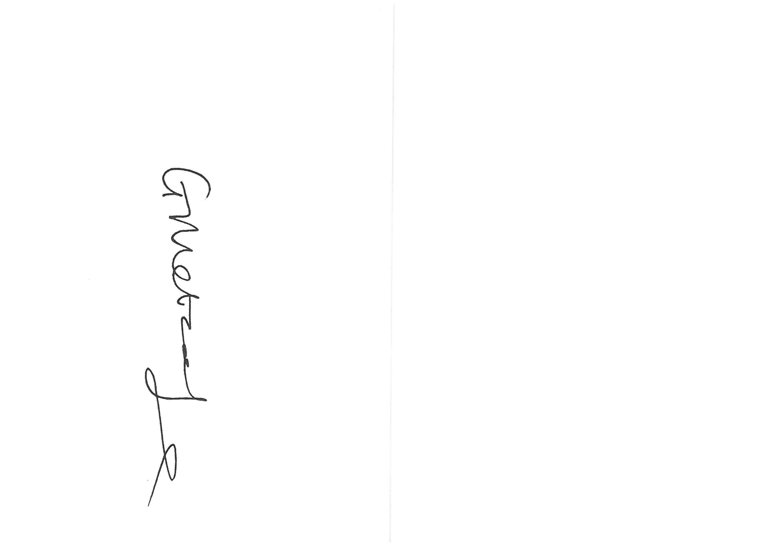
Georgie Metcalfe
Head Teacher
_{Head c}
…………..............................................................…………………………………………………………….

…………………………..……………… was absent from school on ….………………………………………

Due to…………………………………………………………………….…………………………………………………..

Signed…………………………………………………..…………… Date…………………………………….…..……

Notification of Illness
Please can we remind parents that if your child is absent from school please ring us as soon as possible to let us know that they will not be in, but could we please remind you that we also need a written note explaining the absence on the day they return to school. This is very important as we need this to make sure that the school complies with absence regulations. Thank you for your help in this matter.

