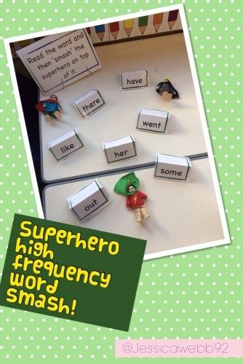

he | we | me | be
she | go | no | was
and | as | I | they

Create tricky word cards to rescue and read or say and smash using superhero figures that you might have at home. Here are some word suggestions.
