Class 4 working from home information for week beginning Monday 12th October
If you are working from home due to having to self-isolate, try your best to complete this work. I will endeavour to match it as close as I can to what we are doing in class, so you do not miss anything. If you would like any work checking or marking, please email messages and photos of your work to the Slingsby Admin team and they will forward it on to me. Do you best to also read to an adult for 15-20 minutes a day.
Looking forward to seeing you again soon.
Miss Secker & Mr. Smith
Monday
English
As usual, please look at your weekly spellings and use a dictionary (paper on internet https://dictionary.cambridge.org/https://dictionary.cambridge.org/) to find the correct definition (meaning) for each word. Then have a go at thinking of a suitable synonym and antonym for each spelling.
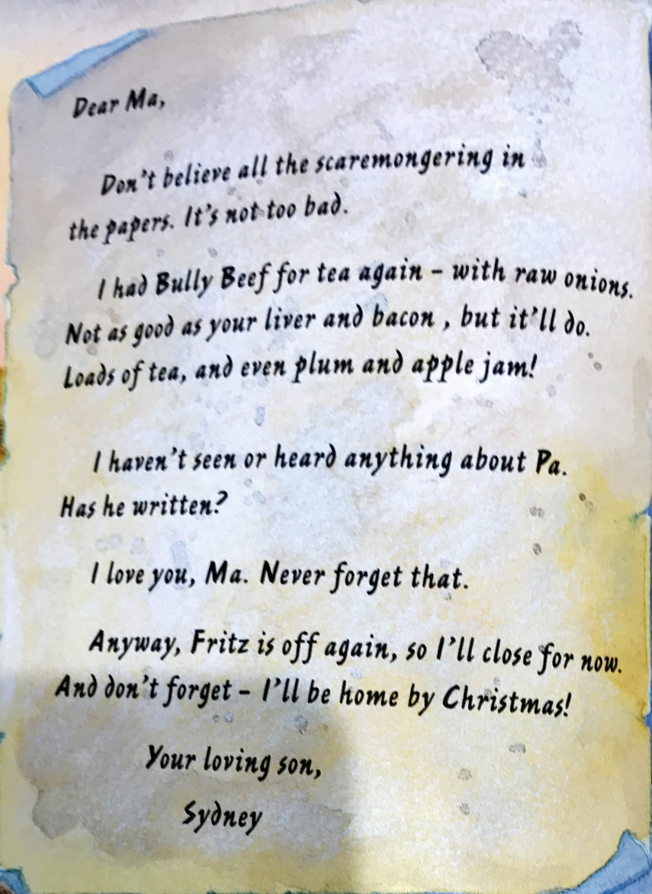
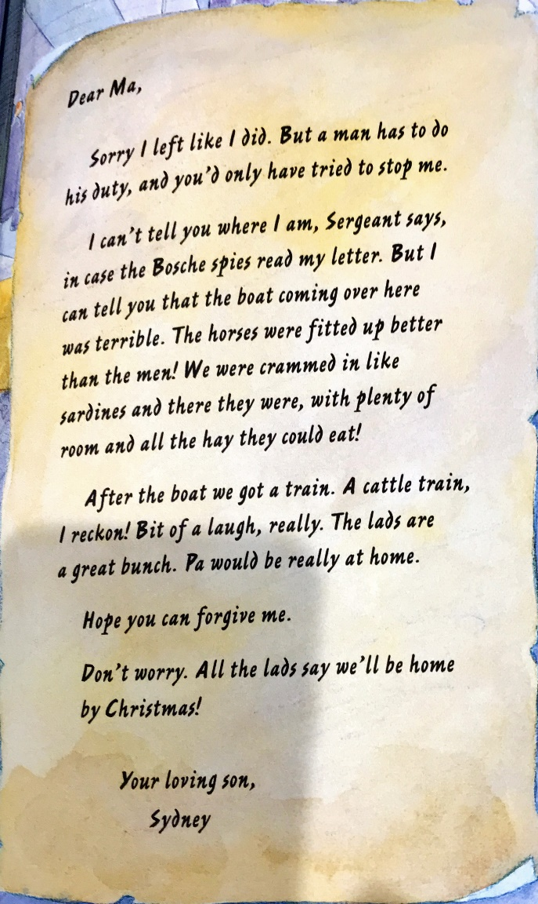
Monday 12th October 2020:Today we will be writing a letter from the point of view of a soldier in the war. Read the letters below from ‘One Boy’s War’. Think about the following points:

- Who is our character (Sydney) writing to?
- What is the tone of the letter? Is it formal or informal? Why might this be?
- Is Sydney being honest about what he is experiencing during the war? Why might he lie to his mum about his experience?

Once you have thought about the above points carefully, you can start to write your own letter from the point of view of a soldier in the war. Think about what he might be feeling at the time of writing the letter. Also, have a think about who you are writing the letter to and what you would want to tell them. Would you want to tell them about all of the horrible things you have seen or would you want to reassure them that you are safe?

Challenge: after you have written your letter, can you pick out one sentence that you would like to improve in some way? Write that edited sentence in green underneath your letter.

Tuesday 13th October 2020:
Look back at your letter from yesterday. Today we will be writing a diary entry from that soldiers’ point of view. Remember, a diary entry is very personal to the person writing it as they will probably be the only one reading it back, so your soldier may write in detail about how horrible the conditions are that he is surrounded by. There is a diary entry template below but you can use your own lined paper if you feel you want more space to write.

Once you have written your diary entry, can you write one star and one wish to understand one strength of your work and one area to improve.

Wednesday 14th October 2020:
Today, we are going to plan an acrostic poem about Flanders Field (one of the main battlefields in World War I which covers Southern Belgium and North-West France).
As it is going to be an acrostic poem, each line of your poem will start with the letters from ‘Flanders Field’.

Make some notes about Flanders Field:
- Adjectives to describe it
- Where it is?
- How was it used in the war?
- What is Flanders Field used for now?

You can write your plan in note form but it must include ideas about what Flanders Field was used for in the war as well as adjectives and expanded noun phrases you could use to describe it.

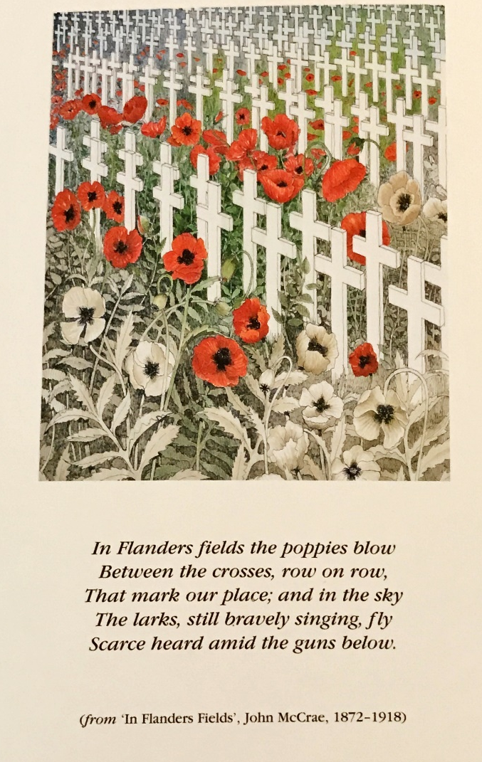
I have included part of the ‘In Flanders Field’ poem by John McCrae below to help you think about what Flanders Field is now used for.

Thursday 15th October 2020:
Today we are going to write our poem on Flanders Field. Use the facts, adjectives and expanded noun phrases you thought about yesterday to help you write your poem.

Remember, we are writing an acrostic poem so the structure should follow the one below:

F
L
A
N
D
E
R
S

F
I
E
L
D

You can choose to include rhyme at the end of each line if you wish. Think about the rhyming scheme (pattern) you would want to include. For example, the words at the end of the first line and third line could rhyme and the words at the end of the second and fourth line could rhyme. You could then include that pattern through the rest of your poem.

Friday 16th October 2020:
Today we will be writing a book review, thinking about the four books we have looked at so far this term. It is up to you whether you choose to review War Horse, War Game, One Boy’s War or In Flanders Field. Think about the main events that happened in the story that you could include (without spoiling the book for someone!). There is a layout below to support you in writing your review.

RE/PSHE
Tuesday 13th October 2020
O LO: Can I think about ‘new beginnings’ in life and how they might make me feel?

This week in PSHE, we are going to be thinking about ‘new beginnings’. This links to our work in RE, where Moses and the Israelites were able to start a new beginning by escaping Egypt and their life of slavery. We outlined last week that Jewish people remember this ‘new beginning’ for the Israelites through celebrating Passover.

Think about any ‘new beginnings’ that may have happened in your life (attending a new school, moving to a new house with your family, a new person joins your family) and think about how they have made you feel. Can you make a mind map to outline how you felt in one of those moments?

New beginnings
How I felt when...

Now think about how friendship, family and support may have helped you during one of these times when something new happened. Create another mind map outlining the things that helped you but also how you feel you could help someone dealing with a ‘new beginning’ or change in their life, even if it is a positive change.

New beginnings
How I could help someone deal with them

Wednesday 14th October 2020
O LO: Can I write about the foods I like and dislike in French?

This week in French, we are developing our sentences from last week to talk about the food and drink that we like and dislike. I have provided cards below to help you write your own sentences in French about the food you like and dislike.
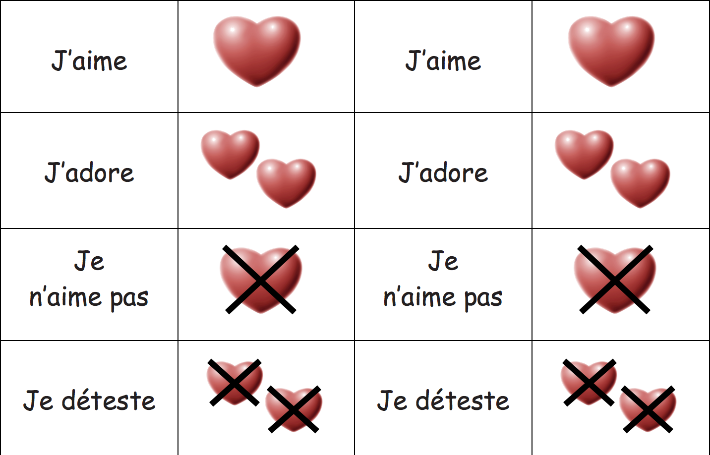

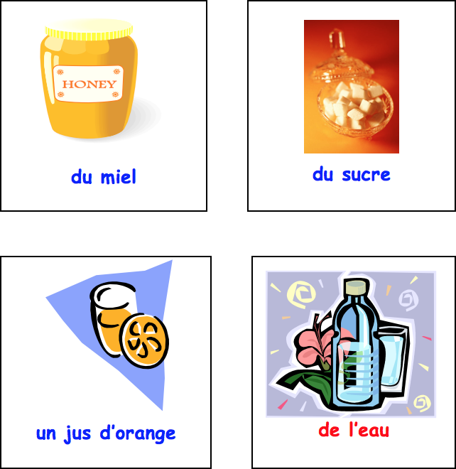

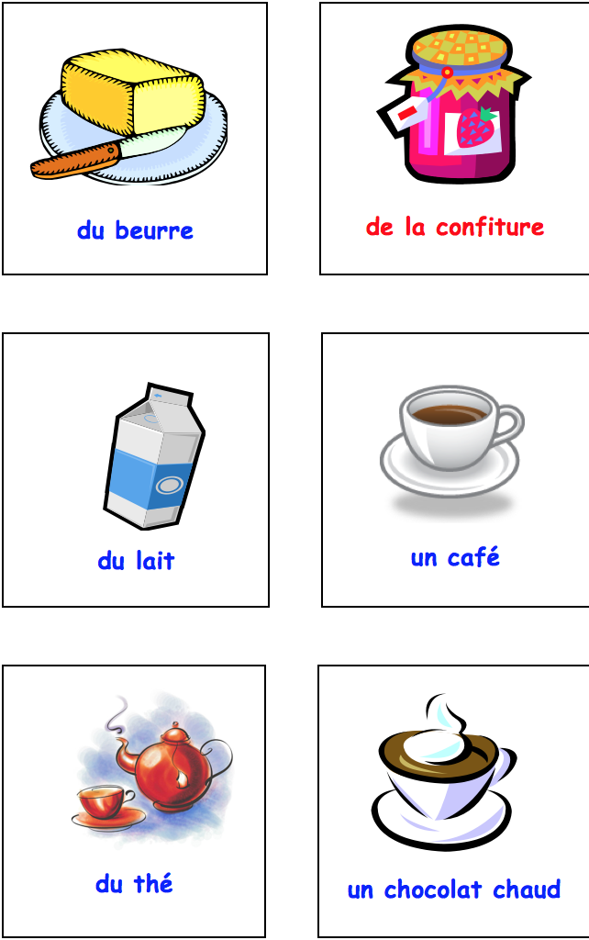
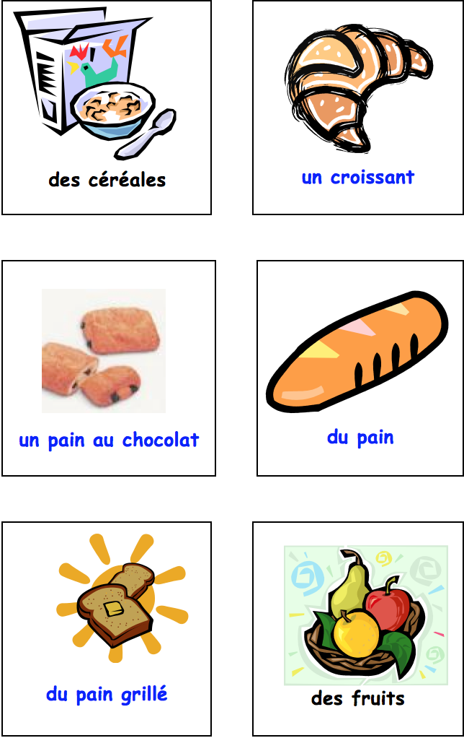

Thursday 15th October 2020
O LO: Can I carry out a fair test to recover salt from a salt water solution?
In the science lesson today we are looking at how we can separate salt from a salt water solution. I have attached a help sheet below to describe how you can carry out the experiment at home and record your results.
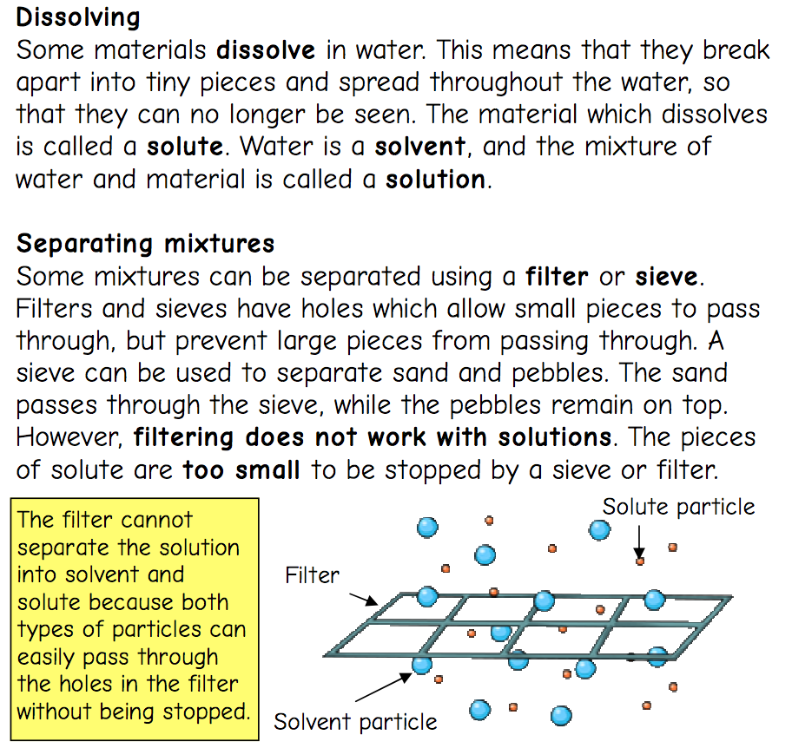

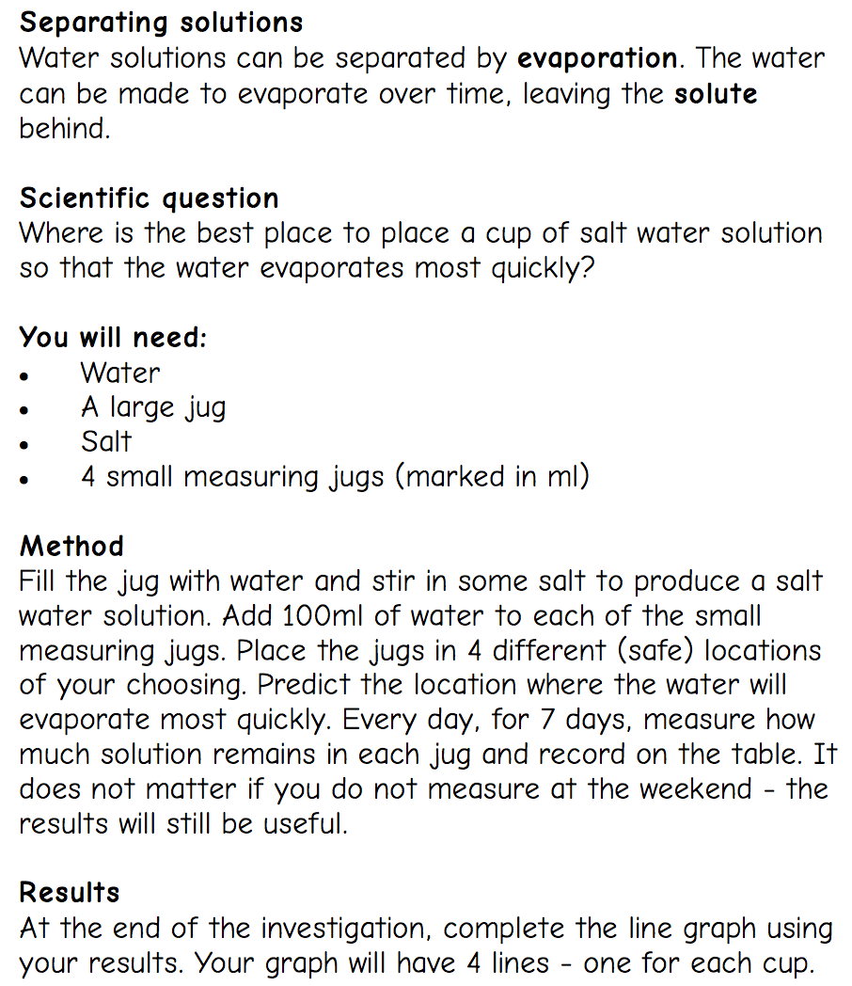

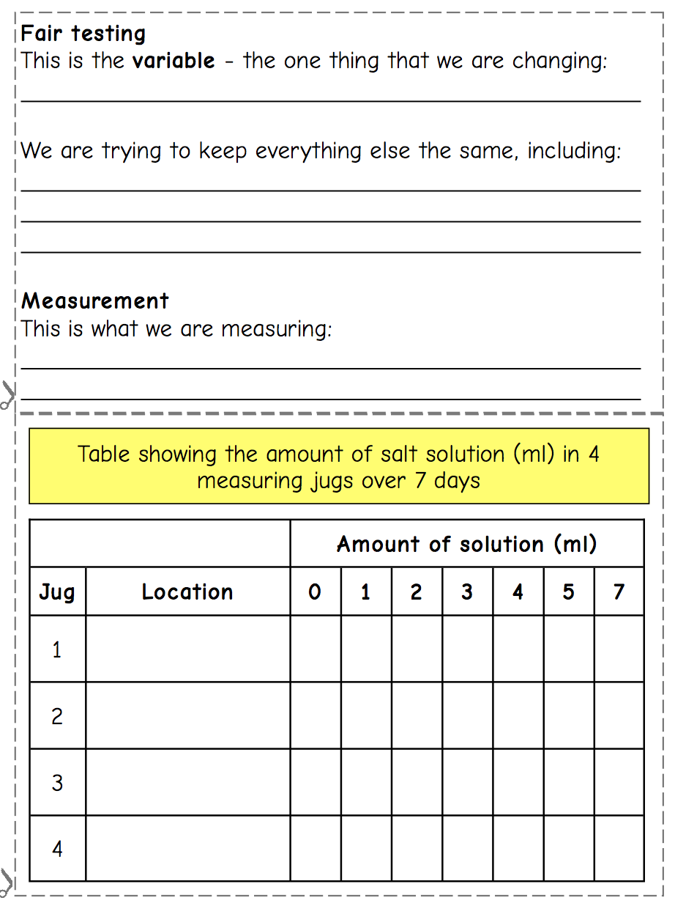

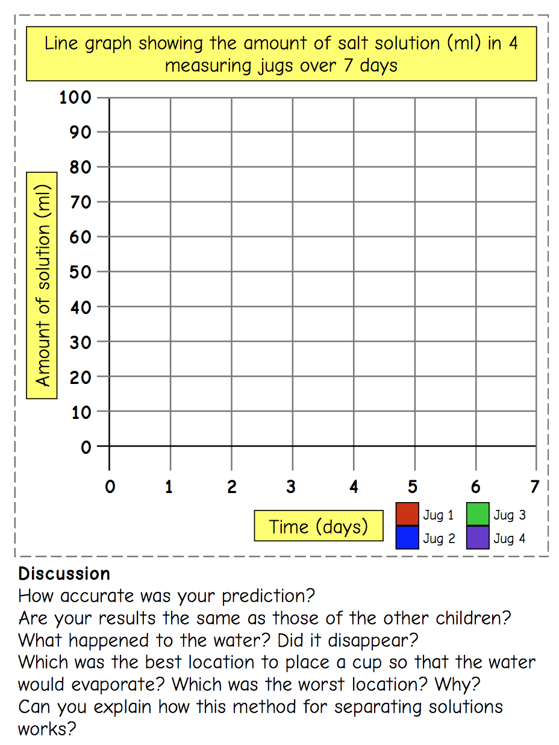

Technology

Design an air-raid shelter which has a working door system and is able to hold a 1kg weight on top without collapsing (to show strength).
When you return, we will be using 10mm square-section dowel for the frame.

- Try to show views from the side, front and top (plan view).
- Include measurements in cm or mm.
- You could also draw cut-away views which show inside your shelter in a 3D drawing.
- Here’s a simple side view and front view of what I will be making, but it also needs measurements and notes adding.

Side elevation Front elevation

Black History Month:

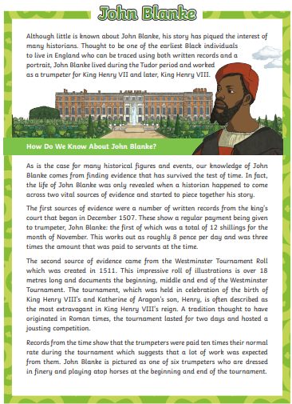
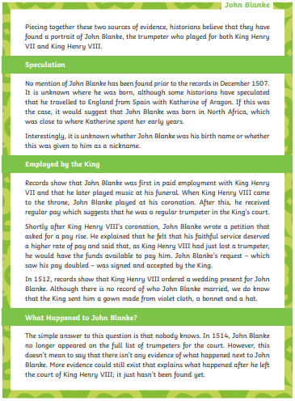

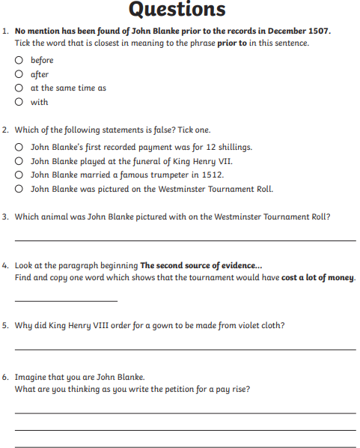

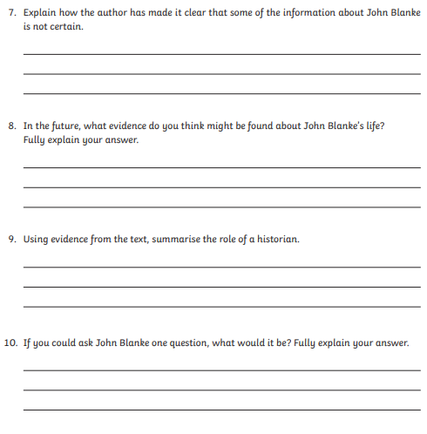

This week’s spelling lists:
Class 4 spelling list for group 4: Week 5
After completing ‘look, cover write, check,’ please try to write 5 interesting sentences in your spelling homework book. You can use more than one word from your spelling list in each sentence.
Objective: The j sound spelt as –ge and –dge at the end of words
Spellings | Look, cover, write, check
 | Monday | Tuesday | Wednesday | Thursday
age
cage
change
charge
huge
page
rage
stage
strange
wage
orange
damage
fringe
cottage
village

Class 4 spelling list for group 3: Week 5
After completing ‘look, cover write, check,’ please try to write 5 interesting sentences in your spelling homework book. You can use more than one word from your spelling list in each sentence.
Objective: Revision of the suffix ‘less’
Spellings | Look, cover, write, check
 | Monday | Tuesday | Wednesday | Thursday
unless
endless
useless
helpless
jobless
headless
needless
sleepless
homeless
harmless
hopeless
pointless
careless
powerless
timeless
limitless
priceless
speechless
thoughtless
stainless

Class 4 spelling list for group 2: Week 5
After completing ‘look, cover write, check,’ please try to write 5 interesting sentences in your spelling homework book. You can use more than one word from your spelling list in each sentence.
Objective: To revise common prefixes – dis and -auto
Spellings | Look, cover, write, check
 | Monday | Tuesday | Wednesday | Thursday
disagree
discover
disprove
disallow
disable
disappoint
disappear
discuss
autograph
automated
automatic
autopilot
autopsy
autobiography
automatically

Class 4 spelling list for group 1: Week 5
After completing ‘look, cover write, check,’ please try to write 5 interesting sentences in your spelling homework book. You can use more than one word from your spelling list in each sentence.
Objective: To revise common prefixes – dis and -auto
Spellings | Look, cover, write, check
 | Monday | Tuesday | Wednesday | Thursday
disadvantage
disappointment
disappearance
dissatisfaction
disappeared
discussion
autobiography
autobiographies
autobiographical
automated
automation
autopsy
autopsies
disagreement
automatically

