Monday 12th October 2020:
Year 5:
Today we are focusing on identifying 3D shapes and their properties by looking at their 2D representation. Look at the shape nets below. Can you:
- identify the shape each net represents
- identify how many faces, edges and vertices each shape would have if it was built into the 3D shape.
Once you have estimated the name of the shape and the number of properties it has and made a note of that, can you cut out the nets to create the shapes and see if your estimates are correct? Then, write the correct number of properties next to your estimate, were your estimates accurate?

Top tips:
Cut the shape out and then score along the dotted lines before folding them.
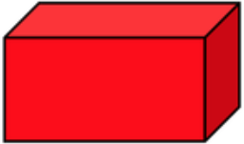
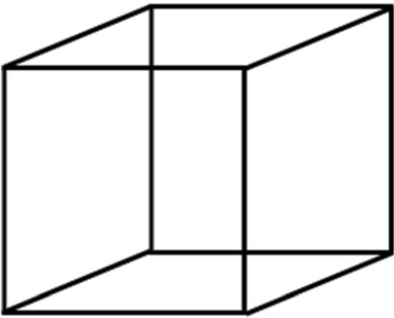
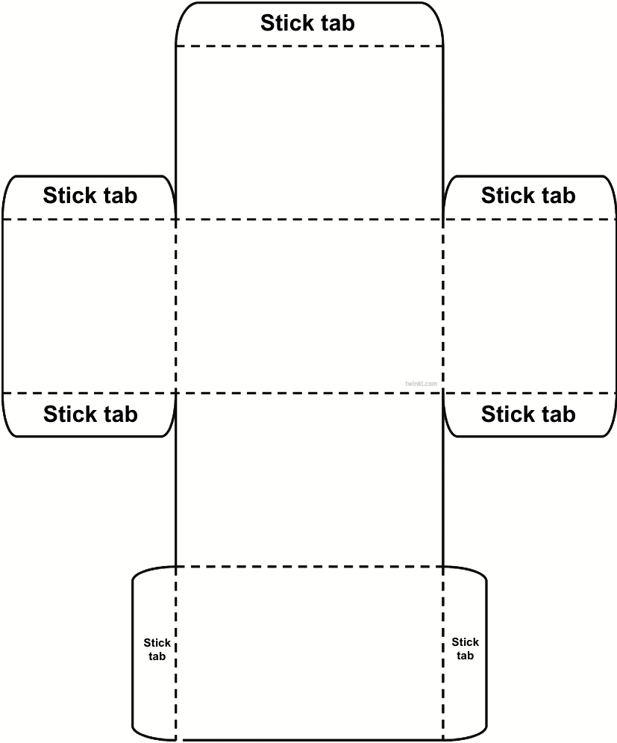
Stick the shape together with a small amount of glue.

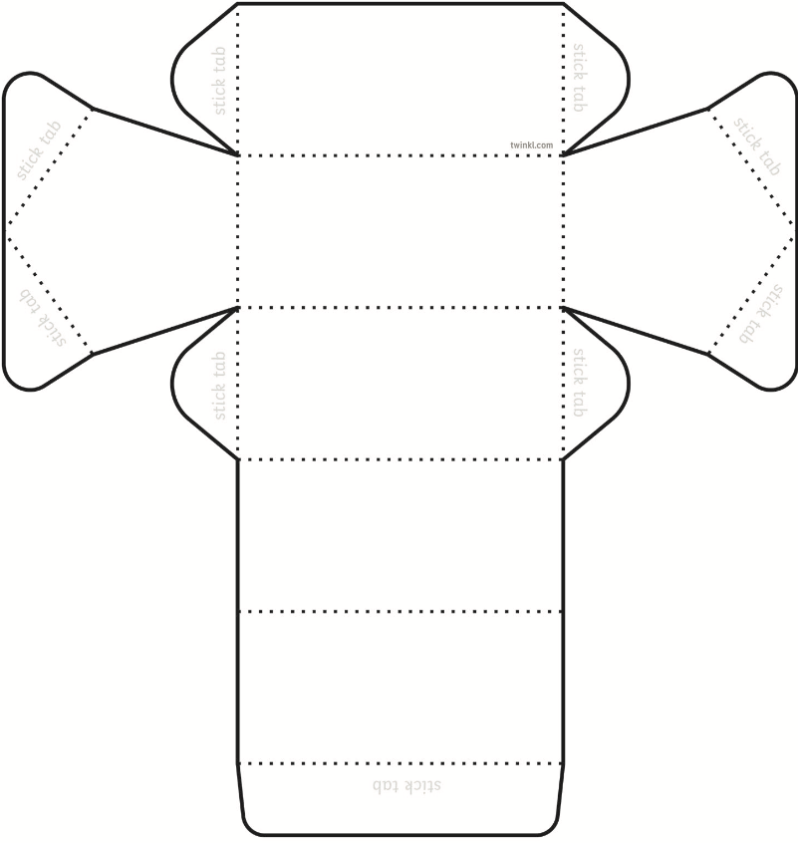
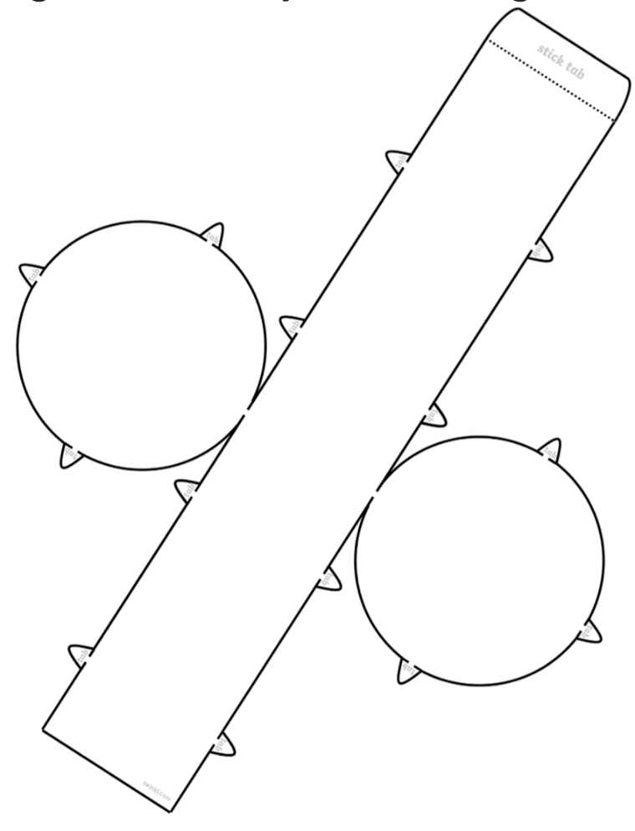
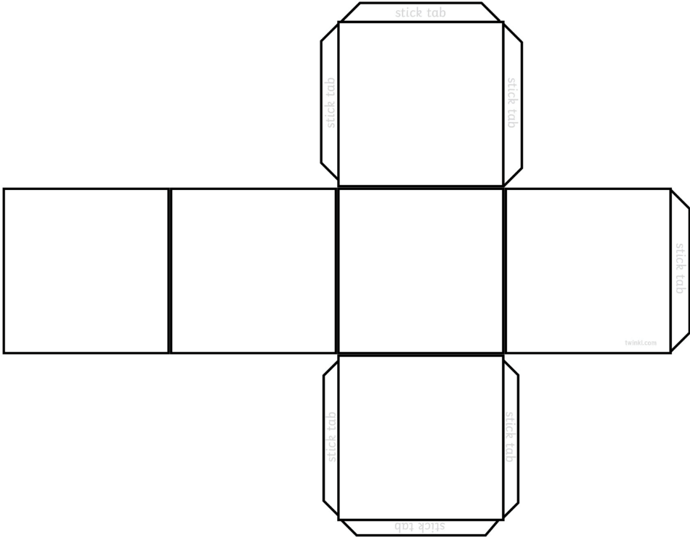

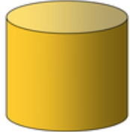
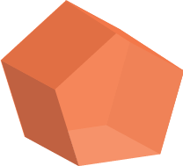
Monday 12th October 2020:

Year 6:
I have included questions below that give a description of a shape. Can you name and draw the shape out, using the lengths and angles provided? Use a ruler and a protractor to help you.

- I am a 2-D, 5 sided regular shape. I have one side that is 5cm long. Each of my angles is 108˚. What shape am I?

- I am a 2-D, 4 sided regular shape. I have four right angles. I have one side that is 7cm long. What shape am I?

- I am a 2-D, 3 sided regular shape. My interior angles are of equal size and they add up to 180˚. One of my sides is 4cm long. What shape am I?

- I am a 2-D, 4 sided irregular shape. I have two pairs of parallel lines. One of my long sides is 6cm long and one of my short sides is 3cm long. I have four angles that are 90˚. What shape am I?

- I am a 2-D, 8 sided regular shape. I have one side that is 4cm long. I have 8 angles and they add up to 1080˚. What shape am I?

- I am a 2-D, 6 sided regular shape. I have one side that is 6cm long. I have six angles. One of my angles is 120˚. What shape am I?

- I am a 2-D, 4 sided irregular shape. I have two acute angles and two obtuse angles that, altogether, add up to 360˚. All 4 sides are 6cm long. I have two pairs of parallel lines. What shape am I?

Tuesday 13th October 2020:

Year 5:
I have included images of some angles below. Can you:
- identify if the angles are acute, obtuse or reflex angles?
- estimate the size of the angles?
- measure the angles using a protractor to see if your estimates are accurate?

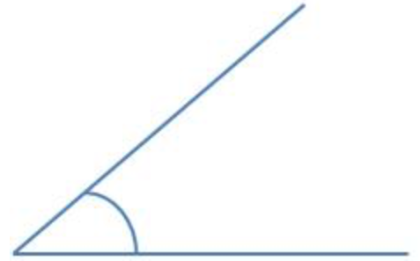

Type of angle:
Estimate:
Actual:
Type of angle:
Estimate:
Actual:

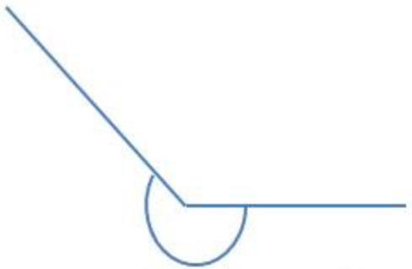
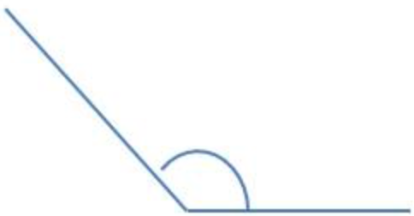

Type of angle:
Estimate:
Actual:
Type of angle:
Estimate:
Actual:

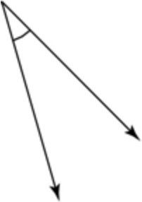
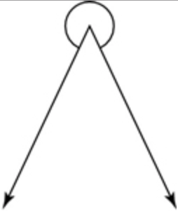
Type of angle:
Estimate:
Actual:
Type of angle:
Estimate:
Actual:

Tuesday 13th October 2020:

Year 6:
There are some triangles and quadrilaterals below. Can you work out the missing angles in each shape? Draw each shape out, labelling the existing angles. Then add in the value of the angle that you find!

Hint:
It is possible to work out the value of the missing angles without using a protractor.
What do all of the angles in a triangle add up to?
What do all of the angles in a quadrilateral add up to?

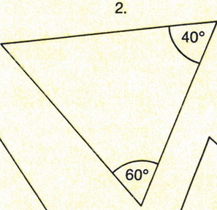
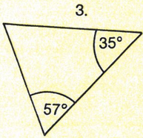
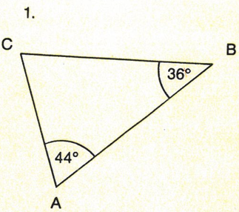

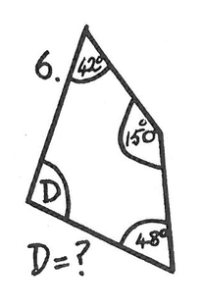
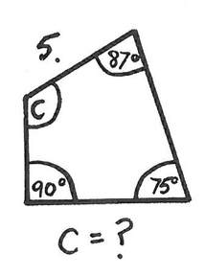
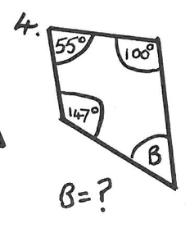
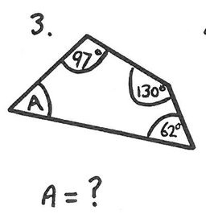
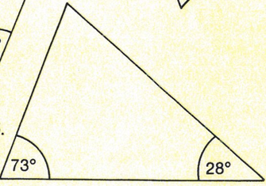
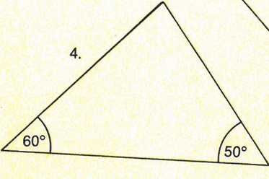

Wednesday 14th October 2020:

Year 5:
Following on from yesterday’s work, it is now your turn to accurately draw angles using a protractor. Draw the angles onto the straight lines next to each number.

- 90˚

- 45˚

- 33˚

- 98˚

- 22˚

- 175˚

- 85˚

- 14˚

Extension:
Can you label each angle that you have drawn as acute, obtuse, reflex or right angle? Explain how you have identified each one.

Wednesday 14th October 2020:

Year 6:
Take a look at the shape work from yesterday. We are going to try and show the angles that we found in the shapes using an algebraic equation. Remembering the two facts below will help you to do this:
The angles in a triangle add up to 180˚
The angles in a quadrilateral add up to 360˚

If we take a look at this question here, we know that we are trying to work out the size of angle C. We can express this in an equation by writing c = 180˚ - (44˚+36˚). This means that, we know that we can take 80˚ (44˚+36˚ or angle a + angle b) away from 180˚ (the amount that the three angles in a triangle would add up to) to find the value of the missing angle. The missing angle, therefore, is worth 100˚. So our final equation is 100˚ = 180˚ - (44˚+36˚).

Can you write fill in the equation c = 180˚ - (a+b) OR d = 360˚ - (a+b+c) for the angles you worked out yesterday (see below)?

Thursday 15th October 2020:

Year 5:
Today we will be looking at using the properties of rectangles that we already know to work out related facts and missing lengths and angles. These facts include:
- rectangles have four straight sides
- rectangles have four right angles adding up to 360˚
- rectangles have two pairs of parallel sides
- rectangles have two short sides of the same length and two long sides of the same length

Use these facts to answer the questions below. If you feel that drawing out a sketch of the shapes would help you answer some of the questions, please do so:

- A shape has 4 right angles, 4 straight sides and 2 pairs of parallel lines. Draw what the shape could be? Is there more than one option?

- Two angles in a quadrilateral are 55˚ and 65˚. The other two angles are an equal size. What is the size of the two missing angles?

- Simon measures the angles of a quadrilateral. He says the angles are 54˚, 110˚, 64˚ and 134˚. Is he correct? Explain your answer.

- A trapezium has one angle of 87˚. What are the sizes of the other three angles? (Hint: opposite angles in a trapezium are the same).
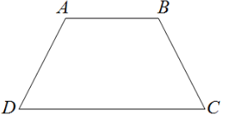
87˚

- The perimeter of the rectangle below is 45cm. Find the lengths of each side of the rectangle. One side has been done for you.

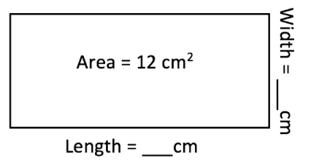
- What could the length and width of the rectangle below be? Is there more than one combination?

Thursday 15th October 2020:

Year 6:
Today we will continue to work out missing lengths and angles in shapes using measurements we have been given already. This time, you will be given descriptions of shapes and their properties. Can you use these descriptions to work out the missing lengths and angles?

Hint: if a question asks if you can demonstrate or work out an answer, try drawing the shape with the missing lengths or angles that you have found to show your working.
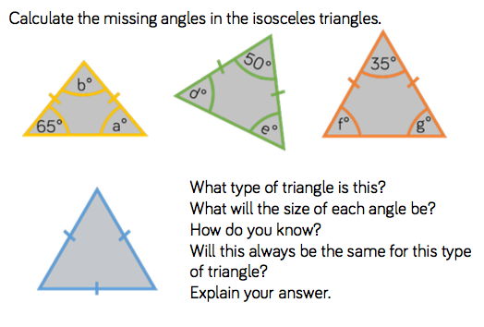
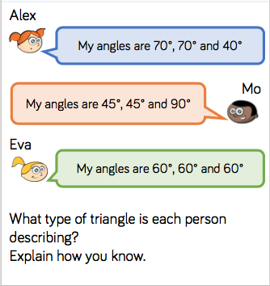
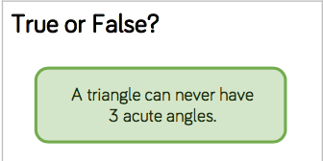
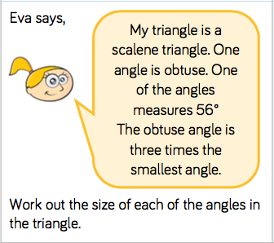
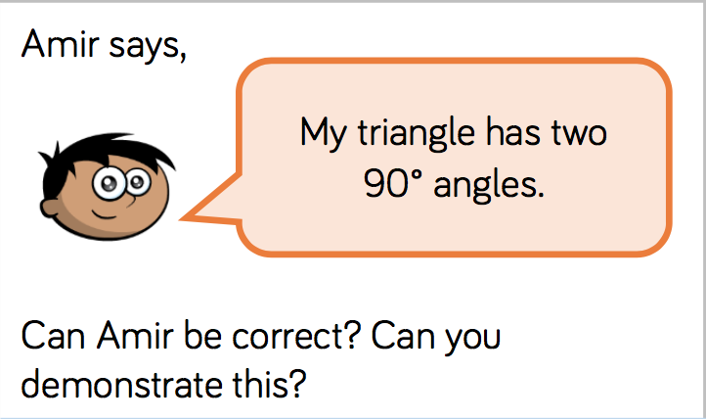

Friday 16th October 2020:

Year 5:
Today we will be focusing on a coordinates grid (see below) and describing and showing the position of shapes after a translation.
When we ‘translate’ a shape, we move it from one place on the grid to another.

Practice questions:
Complete the two questions below so that you can practice reading and plotting coordinates on the grid.
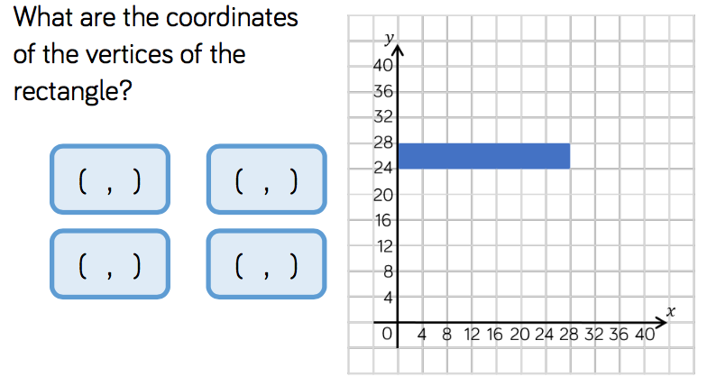
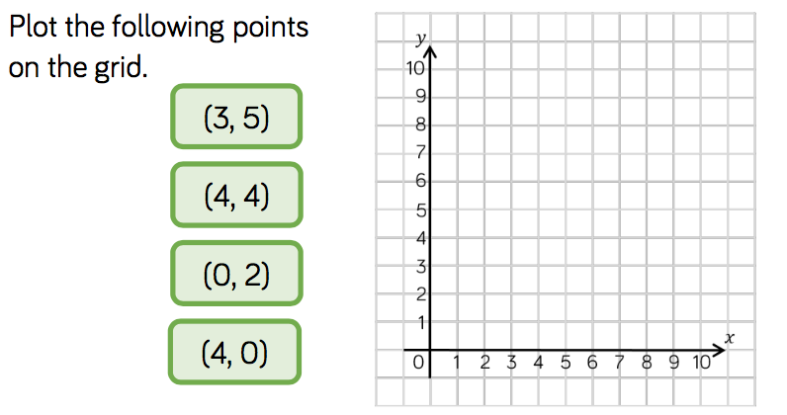
Top tip: move along the corridor and then go up the stairs!

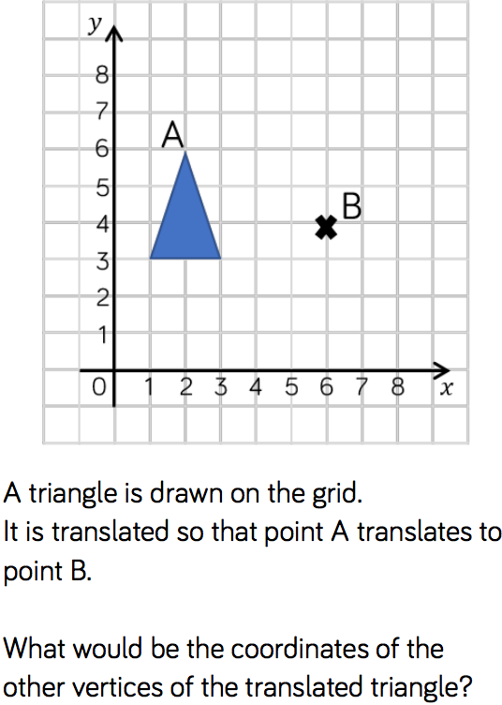
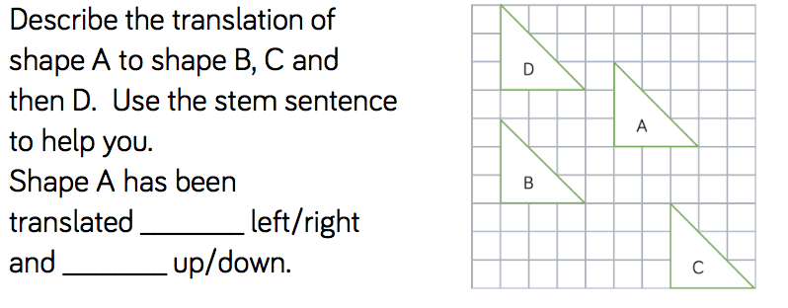
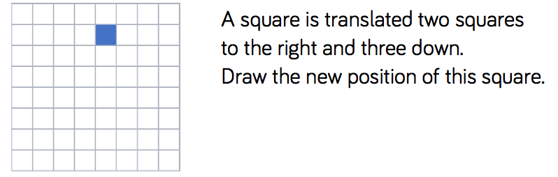

Friday 16th October 2020:

Year 6:
Today we are looking at drawing our own coordinate grid and drawing and labelling quadrilaterals in all four quadrants (sections). Draw out the grid below onto a piece of paper.
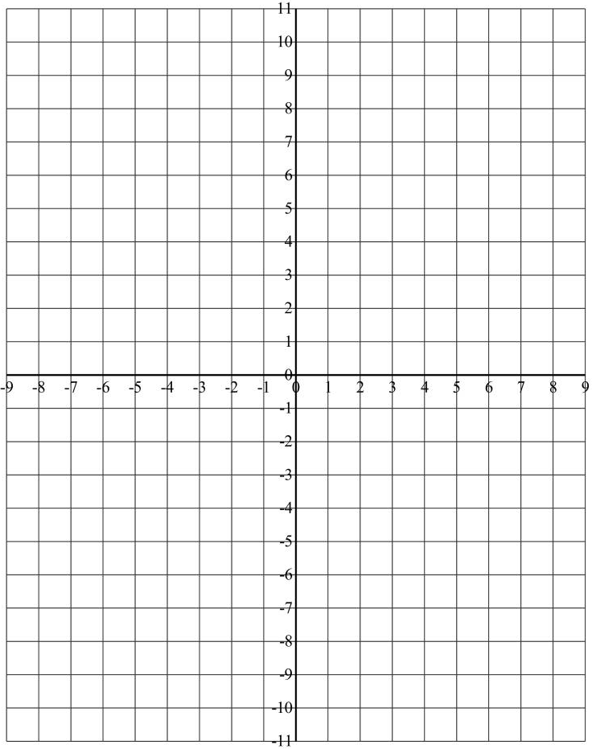

Can you plot the coordinates below onto the grid? What shapes do they make? (Remember to go along the corridor, then up the stairs!)
- (2, 1) (6,1) (2,3) (6,3)

- (-1, 1) (-2, 5) (-6, 1) (-5, 5)

- (1, -3) (1, -7) (5, -3) (5, -7)

- (-2, -2) (-4, -8) (-8, -8) (-6, -2)

