Class 3 Home Learning Week Commencing 2nd November 2020
All of a sudden, we find ourselves in a very different place! I have put together an outline of the weeks learning below please try and complete what you feel you are able to do and not worry if there are somethings that you do no complete. Attachments alongside this document include the maths information, spellings to be learning for the week and any additional resources.
This document will be added to so please check back on here for further updates. If you want to get in touch then please do so through the school admin email and I will get back to you as soon as I can.
I am hoping to upload Youtube videos of the class reader book in chapters over the course of the time we are closed. Please try to ensure that children are reading for at least 15 – 20 minutes per day. All of the children know the times tables that they are learning and if they want to practise they can use Hit the Button or can have a go at loads of games or a test online at timestables.co.uk. joe wicks is going to be back doing regular new home workouts so you can keep active at home – he will be uploading new workouts on Monday, Wednesday and Friday starting next week but you can always go on to his Body Coach TV Youtube channel and search for any of the old PE with Joe videos – keep moving, keep healthy!
Take care of yourselves.
Mr Cash

Morning Activities
 | Morning Task | Maths | English
Tuesday | If…  2 + 5 = 7 what is 20 + 50?  If…  3 + 6 = 9 what is 30 + 60?  If…  5 + 2 + 3 = 10  what is 50 + 20 + 30?  If…  3 + 5 + 4 = 12  what is 30 + 50 + 40? | Maths  LO: I can use column addition with carrying.  See the attached information sheet to help you with the following calculations.  57 + 24 =  73 + 18 =  125 + 36 =  145 + 73 =  256 + 372 =  6782 + 2561 = | LO: I can start to use speech punctuation.  Look at the attached hippo speech sheet.  Look at the first example. Notice how the words in the speech bubble have been put into speech marks to write in sentence form. Outside the speech marks you can describe who said the words and how they said it.  Convert the second example using speech marks and describing how those words might be said. In the third example put the words that hippo said into the speech bubble.
Wednesday | Fireworks maths challenge  Arrange each of the numbers 0 -5 in the circles of the Triangular Firecracker below so that the numbers on each side of the triangle add up to six  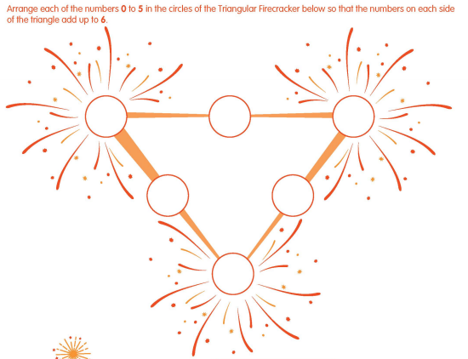  Extension: Arrange the same numbers (0-5) so that the sum of each side adds up to 7. Then try making each side add up to 8, and then 9. | Year 3 Maths  LO: I can use my addition knowledge to solve problems.  Have a go at the problem-solving questions on the attached sheet for your year group.  Use the methods that you have been learning and do your best! There are plenty of questions so don’t worry if you don’t finish them all. | LO: I can use the rules of speech punctuation.  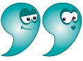  Speech mark rules:  - New speaker, new line  - Speech marks “ “ at start and end of spoken words (direct speech)  - First word of direct speech should be capitalised  - Punctuation included at end of direct speech e.g. , . ! ?  - Add a reporting clause that describes who said the speech and hopefully how they said it, followed by punctuation.  Example:  “Good afternoon your majesty!” squeaked Mr Cash.  Have a go at the activity attached (‘Direct Speech’) – the instructions are on the sheet.
Thursday | Have a practise of your times tables this morning.  Use 2 dice or choose a random number (1 – 12) and multiply it by the times table that you are practising – how fast can you be? | Maths  LO: I can use column subtraction with exchange.  See attached questions.  Please see attached information sheet and Powerpoint for help with the process. | LO: I can use the rules of speech punctuation to write a conversation.  Have a look at the attached sheet called Talking Book.  Can you write out the direct speech in the speech bubbles using speech marks and a reporting clause (to explain who said the speech and how it was said). Remember to use a new line for each new speaker.  Extension:  How do you think the conversation between the girl, the wizard and the book might carry on? Can you continue it?
Friday | Remembrance Sunday will be this Sunday 8th November before Armistace Day on Wednesday 11th November.  Armistace Day marks the day World War One ended, at 11am on the 11th day of the 11th month, in 1918. It is an important occasion to remember and show our respect for those lost.  If you can, watch this lovely animation on BBC Bitesize which shows how the poppy is a special symbol for this event.  Can you have a go at creating a poppy, or poppy wreath, of your own that you could put up in the window of your house?  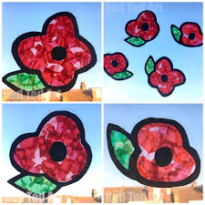  Click this link if you are interested to find out more about World War 1. | Maths  LO: I can use my subtraction knowledge to solve problems.  Please see attached questions for each year group. Pick your challenge – some of the questions will need you to think quite hard about the steps that you need to do. | LO: I can write a short story including speech.  Look at the attached sheet for creative writing.  Can you write a short story that includes some speech?

Afternoon Sessions:

Tuesday | Geography / Science LO: I can describe the features of a river  Building on the learning we did before half term about how a river is formed (remember the tarp and hosepipe setup!)…  For the next three afternoons in class we are going to be constructing a model to show the course of a river from ‘source’ to mouth’.  Hopefully you have access to some carboard, newspaper and glue.  Have a look at the picture of the model will be using for ideas in class (I think you will have seen it anyway) – you will need to start by deciding where your river is going to flow and what features you are going to include (page 3 of the canal and rivers trust info has some good info). You will then need to scrunch up some pieces of newspaper to build up the higher parts of your scene and route which you will lay papier mache over and paint when the glue is dry.  This resource is packed full of information and should help you design what you want your river to look like https://canalrivertrust.org.uk/media/library/31090.pdf
Wednesday | 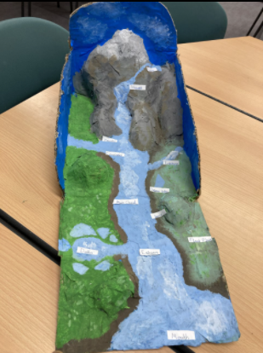  See Tuesday pm  If you do not have cardboard and  newspaper etc to make a model you  could create a poster instead. Page 3 of  the canal and river trust information (link  above) will be particularly useful.  Try to include as much information as  possible.
Thursday | See Tuesday pm  Hopefully you are ready to paint your  Model today.  Using the resources such as the knowledge organiser, which is attached, and those above, can you label the parts of your river system? | Additional Task:  Can you design your own firework?  Make it bright and colourful and Wow!  Can you think of some rules that you need to think about when you are around fireworks/sparklers and use these to create a firework safety poster?
Friday | GENIUS HOUR  This is your free-learning topic time! This week is the start of your new half-term of learning -  Choose a passion and think of a way that you could share your learning with the class and then get started!

