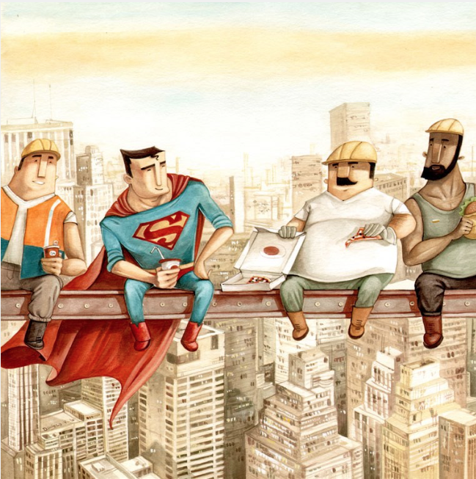

LO: I can write a short story including speech.

Have a look at the picture above. Can you write a short story about what you can see and include some speech between the characters?
- Jot down any words that come into your mind as you look at the picture.
- What are these men doing?
- What do you think they’re talking about?
- Include some speech remembering to use speech marks, a reporting clause and a new line for each new speaker.
- Include some description as well as speech to set the scene.

Once you have written your story, read back over it to make sure it makes sense. What is the best part of your story?

I have written my own example on the next page – I am sure you can do better

Word Bank
High lunch builders superman city massive skyscrapers heights sharing delivery orange sky ‘DeliverSu’ brave fall

Story

After flying around the huge city for what seemed an age, weaving in between the towering skyscrapers looking for his customers, Superman flew in to land on a steel girder where three builders were sat.
“Did you boys order DeliverSu?” Superman questioned, somewhat out of breath.
“We certainly did,” answered the portlier of the builders, sat on the steel bar very high above the city streets below.
The three men shuffled along a little to make a bit more room for Superman to unpack his bags. He unloaded the pizza and drinks that he had been carrying in the large square pack on his bags, passed it out carefully and sat down in between the men in hard hats. This lunch spot was a long way up
“We were startin’ to think ya’ll never make, what with you takin’ so long,” the taller builder, with a thick black beard, sat at the furthest point of the girder said in a strange accent.
The man who looked the boss of the group, wearing a high vis jacket, turned to face Superman “I was beginning to think that the leaflet we saw wouldn’t live up to its promise,” he chuckled loudly.
“DeliverSu deliver anywhere, anytime – that’s the promise!” replied Superman laughing along and helping himself to the last piece of pizza that was being offered to him.

Evaluation
I think the best part of my story was coming up with the name ‘DeliverSu’ – you see what I did there right?!

Also, I think I used speech punctuation accurately and remembered to start a new line for each new person.

