Home Learning for w/c 9th November 2020

Hi Class 2

I hope you are all well and managing to keep busy, stay safe and look after each other. These are unusual and maybe difficult times for everyone but I know how brilliant you all are and I’m positive we can get through the next few weeks.

I have seen some amazing examples of work and it is wonderful to be able to see the work you are completing and how much effort you are putting in – keep it up. In particular, I have been very impressed with the standard of presentation and handwriting.

In the work for this week; both Miss Pearce and Miss Ashton who had a wonderful day with you last week have added to this weeks’ learning from home.

I have added our class timetable below as this might help with the structure of the week but just work through what you can.

Take care and I look forward to seeing you all soon.

Mrs Jordan

Maths

I have made a separate document for maths and this can be found under the weeks work under class 2.
Phonics

Brilliant news! We have updated our school membership to Phonics Play and I have attached below the login details. There are a range of games for the children to access to practice reading the sounds we have been covering in class. We have been focussing on either stage 3 (Mrs Swallow’s phonics session) or phase 5 with Mrs Jordan.

I have also included a phase 3 activity; for you to write the words using sounds learnt and a word search for phase 5 with the ph sound.

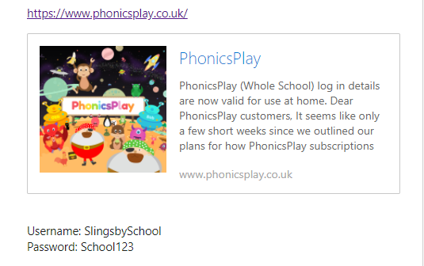

Reading

This is a brilliant opportunity to do some extra reading. Why not dial up grandparents or another family member on the phone or I-pad and offer to read them a story. Can you tell them about the characters, what type of story it is. You could even get them to predict what might happen at the end of the story. Any reading is brilliant whether it is the book from school or a book of choice from home.

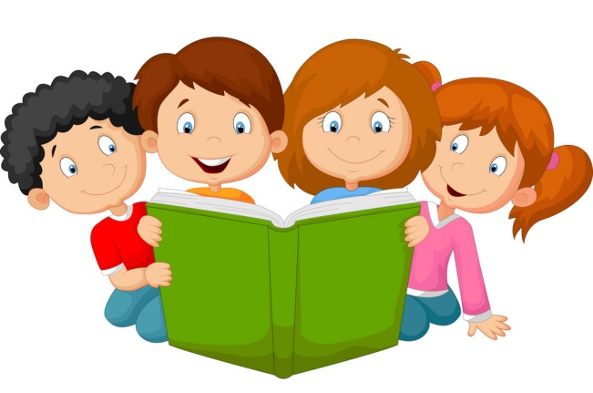
Remember to use your phonic skills that we have been practicing and break the words down, sound out and then blend them back together.

For the more experienced readers in the class, you challenge is to ensure you understand every word you have read. If you come across a word and don’t know what it means please find a dictionary and find the word or ask a grown up.

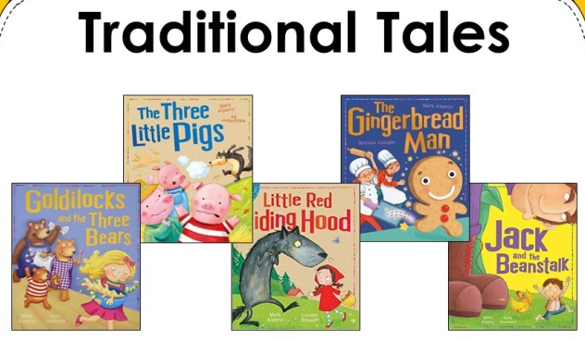
English

Our focus for this half term is Traditional Tales. As part of this we will be doing some descriptive writing, sentence structure work as well as letter and diary writing. We will read some traditional tales with a twist and write our own.

I would like you to start by thinking about the following questions:

- How many traditional tales can you think of?
- See if you have any at home or can watch any on You Tube. How do they usually start and end?
- Where is a traditional tale often set?
- What are some of the characters?

A traditional tale is a story that has been passed from one generation to another. This means it might be a story which is often re-told without a book from a grand parent to a parent to a child and it often changes slightly depending on who tells the story. (Please see my video where I will re-tell the story of the Elves and the Shoemaker without using a book)

Traditional tales usually have animals in them that can speak and often have a good character and a bad character. They usually start with ‘Once upon a time’ and end in ‘and they all lived happily ever after’. Traditional tales are written across many different cultures.
I have given suggested pieces of English for each day, but you can do these in any order.

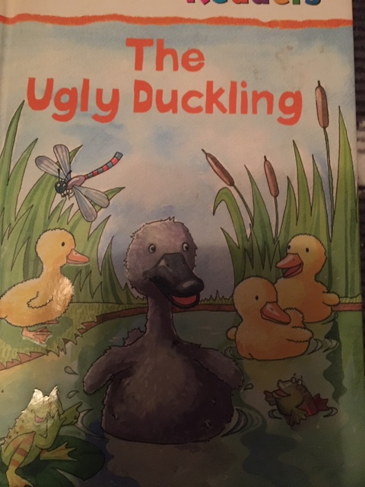

Monday
After having a go at answering some of the questions above and seeing which traditional tales you may have at home. Read the blurb (the information from the back of the book).

The blurb tells us a little bit about the story without telling us the whole story. Read the example above from ‘The Ugly Duckling’.

What I would like you to have a go at today is writing the full blurb or a sentence for your favourite traditional tale. This could be ‘The Gingerbread Man’, The Three Little Pigs’, ‘Cinderella’, Little Red Riding Hood, The Three Billy Goats Gruff or maybe Hansel and Gretal? There are lots to choose from.

Once you have had a go at writing the blurb, can you read this to someone else and see if they can guess the tale? You can then add some wonderful drawings to your writing from the story.

Tuesday
Now you have written your blurb for your favourite traditional tale can you choose your favourite character, draw it and then write a description to tell me all about them. Remember to use noun phrases to describe to your character.
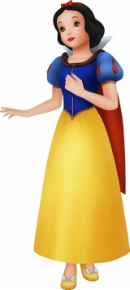
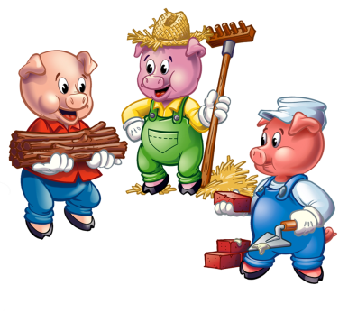
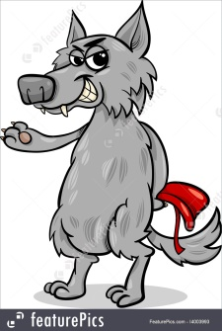

Wednesday
Today can you re-tell your favourite tale. You can either do this verbally as I did or you can write a few sentences or the part in the story where there is more repetition; or if you are feeling confident you could have a go at writing the whole traditional tale. (It is difficult to provide a template as I would like you to choose your favourite tale, however what you could do is share the writing with your child. They write the start – Once upon a time and then you write the next section and then they write and so on)

If you decide to re-tell the story in your own words then maybe you could make some finger puppets out of paper, you could use lolly sticks or wooden spoons or even stick a picture onto a stick from the garden.

Thursday

I would love to see if you can design a new front cover for your book. Can you even give it a new title? For example ‘The girl in the red cloak’, The family of pigs’, The Billy goat triplets’.
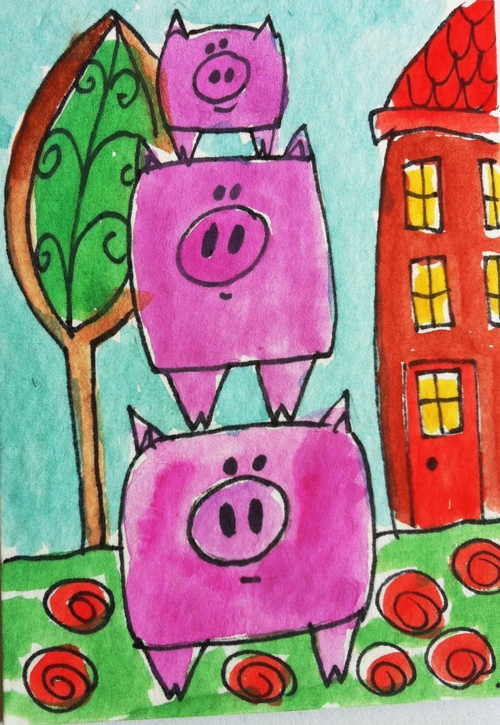

The Pigs that built a house

Friday
The last day of the week and I thought today we would have a Spelling, punctuation and grammar lesson about verbs and adverbs. Have a look at the video that will be posted for today. If you are not able to view the videos please let me know and I can email the work to you.

The focus with all of your writing this week is to use capital letters, full stops and exclamation marks where possible. Can you use your phonic skills to sound words out and have a go at writing them? It might help to say the sentence out loud first.

I would like to see your short sentences joined by using coordinating conjunctions, remember the acronym FANBOYS – for, and, nor, but, or, yet, so.
Science

Why do leaves fall off trees in autumn?
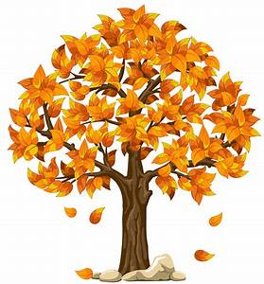
Have you ever wondered why leaves end up on the ground in autumn? There’s an important reason - it’s how deciduous trees (ones that drop their leaves) protect themselves.
Think about the weather in autumn and winter – it gets cold, stormy and there’s a lot less sunshine. This isn’t great for leafy trees.
- A tree covered in flat, wide leaves is more likely to get damaged in windy weather. This could cause branches to break or the whole tree to blow over!
- Leaves contain a lot of water which could freeze in winter, causing the leaves to burst.
- Leaves use sunlight to make food for trees. But shorter days in autumn and winter mean leaves would be quite useless and trees would actually waste energy by keeping their leaves.
So, to give themselves a better chance of survival, deciduous trees shed their leaves in autumn and grow new ones in spring.
Top fact: the scientific name for leaf drop is abscission.
Fallen leaves are great for wildlife!
Many creatures live in leaf litter (the piles of leaves that cover the ground). Earthworms, millipedes and woodlice also feed on fallen leaves. They break them down into tiny pieces, releasing nutrients back into the soil. These animals are known as detritivores.

There are two main types of tree
Deciduous trees drop leaves in autumn. Their leaves are usually flat and wide.
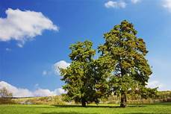

Evergreen trees stay green all year round. Their leaves are tough and often needle shaped.
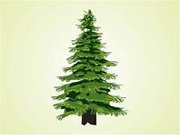

Activities
Can you investigate these trees and find out if they lose their leaves or not?
Rowan, Scots Pine, Holly, Hazel, Oak.
You may have these trees in your garden. Can you identify them and draw their leaves? If not, can you investigate what their leaves look like and draw and label them? (The Woodland Trust website is a really excellent resource for this).

Make your own leaf lantern
My daughter and I collected some fallen leaves from our garden to use for a lantern. We found lots had tiny slugs and snails underneath so keep your eyes peeled! Here is her lantern…
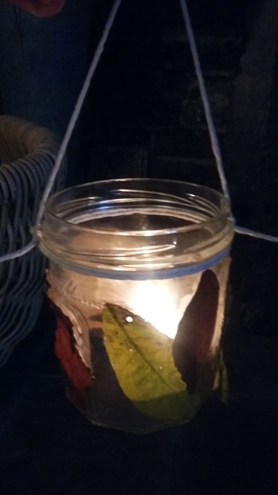
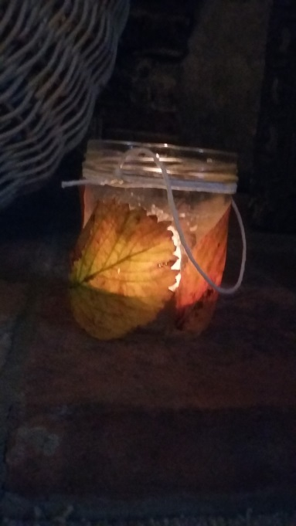

If you would like to make a lantern too, you will need:
- a glass jar
- colourful fallen leaves
- PVA glue
- string or ribbon
- a battery powered tealight
How to make
- Gather a selection of autumn leaves in different shapes, colours and sizes. Remove the stems.
- Apply a thin layer of glue to each leaf and carefully place them on your glass jar. Hold them down for a few seconds to ensure they stay in place – you might need to add some glue over the top to keep them secure.
- Overlap the leaves, leaving some gaps to allow the light to shine through when the tea light is on.
- Wait until the glue is fully dry and then tie some string or ribbon around the top of the jar to finish it off.
- Turn your battery powered tea light on, gently place it in the lantern and enjoy the lovely warm glow it gives off.
Top tip: we let our leaves dry for a few minutes and squashed them between two heavy books to make them flat.
Can you identify the trees your leaves came from? If you need some help, go to the Woodland Trust website and search for tree ID for kids and download the tree ID sheet.
You could bundle up in your warmest clothes, ask a grown up to make cups of hot chocolate and take your lantern outside to enjoy it in the fresh air, in your garden or even just a doorstep. You could even bake a tasty treat to enjoy with your drink…

Leaf cookies
If you like to bake you could try and make these spicy gingerbread cookies. Why not choose your favourite leaf and draw it on some cardboard and use that as your biscuit template?
Ingredients
350g plain flour
175g brown sugar
1tsp bicarbonate of soda
2tsp ground ginger
1tsp ground cinnamon
125g butter
1 egg
4 tbsp golden syrup

How to make
- Sieve the flour, ginger, cinnamon and bicarbonate of soda into a large bowl. Add your butter, combining everything until the mixture looks like breadcrumbs
- Add the sugar and mix in.
- Beat your egg and golden syrup together in a separate bowl. Add the eggy golden syrup mixture to the other bowl and use a mixer to combine everything. Stop mixing when it starts to clump together.
- Knead the dough on a floured surface, then place it in the fridge for 15 minutes.
- Line two baking trays with greaseproof paper. Get an adult to preheat the oven to 180C/160CCFan/Gas Mark 4.
- Unwrap your dough and roll it out on a floured surface. Cut your cookies out using your leaf template.
- Place them onto the baking tray and get an adult to put them in the oven for 12-15 minutes until golden and firm.
- Enjoy!!
Is this a reversible change?

Theme / Art

On the 11th November is the hugely important Remembrance Day. I have attached a power point that explains a little bit more about why it is so important.

Below is a great animation from CBeebies as well as another short video that explains why the poppy is significant.

https://www.youtube.com/watch?v=wOT5CDnYHEs

https://youtu.be/AGCHk5_2skY
- Remembrance Day is marked on 11th November and a special memorial service is held on the Sunday closest to the day.
- Remembrance Day is observed to remember and pay tribute to all those who died in World War One and subsequent conflicts.
- The 11th November 1918 at 11am is when the armistice treaty was signed marking the end of the First World War.
- The poppy started growing in one of the battle fields after the war had finished and it was decided to use the poppy as a symbol of remembrance.
- You may see people wearing a poppy on their coats which they will have bought from people selling them on behalf of the Royal British Legion.
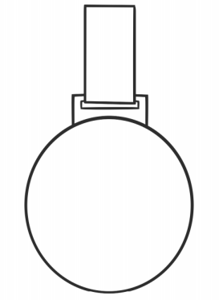
Activities
On the work for Class 2 there is a medal template or alternative medal designs. Can you design and create your own medal for a soldier and think about why it should be awarded? Could it be for someone who has saved his friend? A soldier that has made an important tactical decision? What about a nurse or medic, going above and beyond to help someone else?

Can you make your own poppy using a section from an egg box like the picture below. Alternatively, can you use a potato to print poppies like those in Flanders Fields or use your thumb print. I would love to see your pictures or poppies and you can send these into the admin email address. Can you be creative with the different materials that you have at home. If you don’t have red paint you could look through a magazine and cut out all of the red sections.

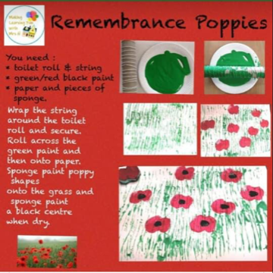

PE

If you are at home it is important to get as much fresh air as you can, why not play a game of catch in the garden, create your own boot camp or obstacle course. You could practice your balance, climb over things and under things as well as practicing your target practice.

PHSCE
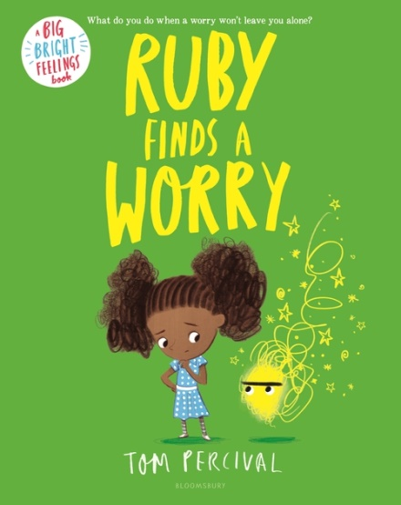
This can be a worrying time for everyone and we might be feeling a range of different emotions. Below is a story called ‘Ruby finds a worry’, it helps us to understand the importance of talking to someone as this can help us to make the worry smaller or even disappear. As an activity you can use the template to draw your worry and say how you can make it shrink.
https://youtu.be/VCyiiHI2SJU

