One Week’s Ration for an Adult

3 pints of milk

8oz Sugar

2oz Tea

2oz Butter

4oz Margarine

3oz Lard

3oz Cheese

4oz Bacon

Meat. To the value of 1s. 2d. (6p today)

2oz Sweets

2oz Jam

1 Egg

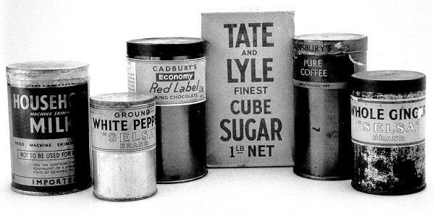

*A child’s ration was exactly ½ the adult’s ration.

Conversion Chart:

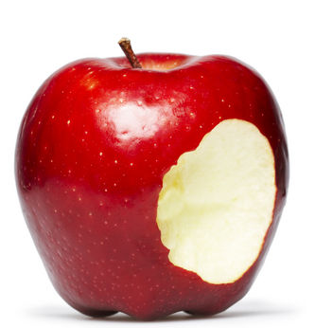
1 pound (1lb) = 453g

1 ounce (1 oz) = 28g

1 pint = 568ml

