Rationing 1939 - 1954
Family Rations Quiz

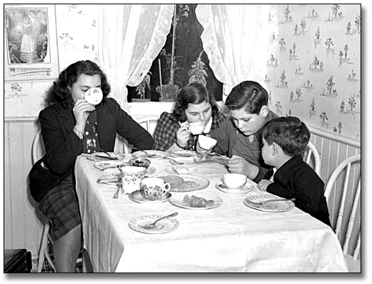
- How much jam will this family get each week?
5 oz 10 oz 12 oz

- How much butter will this family get each week?
20 oz 4 oz 5 oz

- How much lard will this family get for four weeks?
20 oz 30 oz 40 oz

- If an adult gets 2 oz of sweets each week. Which is the correct weight of sweets the children will get each week altogether?
6 oz 3 oz 8 oz

- If an adult gets one egg each week. How many eggs will the family get for 4 weeks?
20 10 15.5

- How much cheese will the family have for two weeks?

30 oz 7 oz 15 oz

- How much milk will the family have for a week?
12.5 pints 7.5 pints 17.5 pints

