French: the months of the year
Bonjour Classe Trois,
Today we are learning the months (les mois) of the year (de l’année).
- Start by saying the months of the year in English: January, February, March, April, May, June, July, August, September, October, November and December.

- How many months are there in total?

- Now listen to the song on this clip (Youtube: parental supervision required) https://www.youtube.com/watch?v=7_u2SigckNQ

- Do you think you can list the months in French? Play the song again a couple of times.

- Here are the months in English and French. Note that in French there is no capital letter at the start of the word.
January | janvier
February | février
March | mars
April | avril
May | mai
June | juin
July | juillet
August | août
September | septembre
October | octobre
November | novembre
December | décembre

- Now try this word search. Bonne chance! (Good luck!)
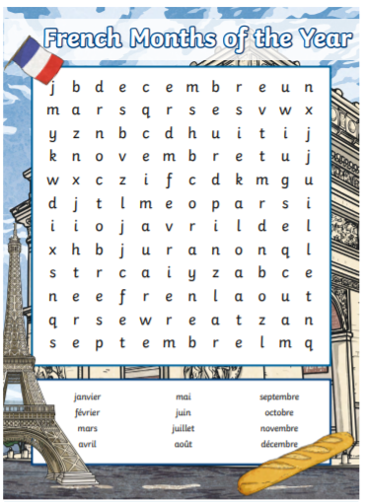

- Write a list of the months in French, and draw something associated with that month next to it. It could be a celebration, such as Christmas, or perhaps someone’s birthday.

And finally, listen to this catchy song which asks when your birthday is – play it a few times and I bet you’ll be singing it for the rest of the day! (Youtube: parental supervision required)
https://www.youtube.com/watch?v=uq1Pf1i-w2A

Au revoir tout le monde!
Miss Armit

