We are learning about Islam, which is the second most popular religion in the world.
Let’s find out about Islam
- Islam was founded in a place called Mecca, in Saudi Arabia around AD610 – that’s more than 1, 400 years ago.
- The language spoken in Saudi Arabia is Arabic.
- Islam is the name of the religion. The people that follow this religion are called Muslims.
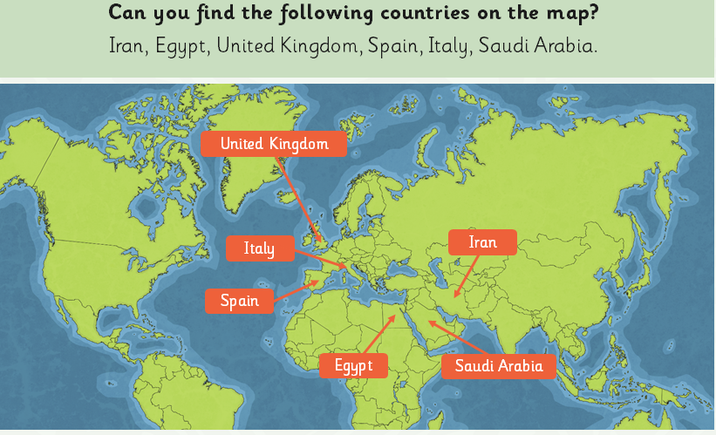
- Muslims believe in one god called Allah.
- Allah revealed His holy book to Muhammad. Muhammad is a prophet as he went on to spread the word of Allah.
- This holy book is called the Qur’an: do you know what the holy book that Christians use is called?

The Five Pillars of Islam

- The Five Pillars of Islam are the things that a Muslim must do to lead a good and responsible life. Just like the pillars holding up a building to keep it strong, Muslims follow the Five Pillars of Islam to keep their faith strong.

Watch this short video - https://www.bbc.co.uk/teach/class-clips-video/religious-studies-ks1-the-five-pillars-of-islam/zv84jhv
The Five Pillars are:
- Muslims declare their faith. This means they think about what they believe, then actually say out loud that they believe in Allah, using a special set of words. The Arabic word for this is Shahada.
- Muslims try to pray five times each day, at sunrise, midday, late afternoon, sunset and nightfall. This is called Salat. They pray at home, or work, or at school, or in their holy building, called a mosque.
- Muslims give a certain amount of the money they earn to charity. This helps others, and also helps them to remember and appreciate how fortunate they are. This is called Zakat.
- In the holy month of Ramadam, Muslims who are fit and well must fast during daylight hours. This means they do not eat or drink anything during the day! This encourages them to feel more spiritual and a part of the worldwide Muslim community. This is called Sawm.
- Every Muslim should go on a pilgrimage at least once in their life to the place where Islam was founded. This holy place is Mecca, in Saudi Arabia, and the pilgrimage is called a Hajj.

Activity for you to do
Often Muslims will kneel on a special prayer mat when they pray. These mats are patterned, often with rich vibrant colours. Have a look at these examples. Can you see how some have symmetrical patterns. Others point forward, so they can be pointed toward the holy city of Mecca. Have a go at designing and colouring your own prayer mat.
